THE LOOKING GLASS BEAUTY SCHOOL

Electric File (E-File) Nail Technique CPD Course — Learner Manual
Course author: Jessica Jane Preston
Document review: Version 1.0 — November 2026 | Review by November 2027 or sooner if law, equipment or guidance change
Continuing Professional Development (CPD) activity — not a regulated qualification.

Document control and permitted use
This manual has been prepared for The Looking Glass Beauty School's Electric File (E-File) Nail Technique CPD Course. It is designed to support qualified nail professionals in learning and demonstrating the safe, controlled use of an electric file in the nail services they already provide. It does not replace machine-specific instructions, product-specific training, an insurer's requirements, local-authority conditions, a Safety Data Sheet (SDS), or medical advice.

Intellectual property, trademarks and images
Original diagrams in this pack were created specifically for this course and are owned by The Looking Glass Beauty School. Clinical photographs are reproduced from openly licensed sources under Creative Commons terms; every image is credited beneath its caption and listed in full, with author, licence and source, in the school's image credits and licence register, available to learners and assessors on request. Brand names are not used to imply endorsement. Where a tutor identifies a machine, a bit or a product during a live demonstration, the name is used only so learners can follow that maker's instructions. Product labels, logos, screenshots and third-party photographs must not be copied into the course unless the school holds written permission or a suitable licence.
SCOPE BOUNDARY — This course teaches the safe use of an electric file on healthy natural fingernails, on the nail coatings and enhancements the learner is already qualified to apply and remove, and on healthy toenails for the removal of those products only. It does not teach the application of any product; the reduction of thickened, damaged or diseased nails; the removal of hard skin or calluses; or any podiatry procedure. Learners use the electric file only on products they are trained and insured to work with.

Course author
I am Jessica Jane Preston, a qualified nail professional, beauty educator and salon co-founder with more than fourteen years of industry experience. I hold a VTCT Level 2 NVQ Diploma in Nail Services and an Award in Education and Training. Since 2021 I have delivered classroom-based beauty education and have trained more than 400 learners. My CV and qualification certificates are available from the school on request.

Important professional boundaries
- A nail professional observes, records, adapts, postpones and refers; a nail professional does not diagnose a disease or prescribe medical treatment.
- Never 'test' a bit, a speed or a pressure on a client's natural nail. Learn on practice tips and on cured product; the natural nail is not a practice surface. Suspected acrylate allergy (including to filing dust) requires medical assessment, not a salon test.
- Do not rely on this manual to override a product label, SDS, manufacturer system guide, local licence condition or insurer instruction.
- Where an urgent reaction includes breathing difficulty, collapse, rapidly increasing facial or throat swelling, or other signs of a medical emergency, call 999. For non-emergency concerns use a pharmacist, GP or NHS 111 as appropriate.

Chapter 1 — Course specification and learning journey
What learners can expect, who the course is for, and how competence is assessed

Course title
Electric File (E-File) Nail Technique CPD Course
A NOTE ON NAMES — Clients, suppliers and social media call this tool a 'nail drill'. It is not a drill: a drill bores holes, and an electric file abrades a surface. This course, the school's advertising and client records use 'electric file' or 'e-file', because the word 'drill' frightens clients and describes a technique that must never be used. The lay term is explained to learners so they understand what a client is asking about.

Course description
The Electric File (E-File) Nail Technique CPD Course is a practical skills-development activity for existing nail professionals who already apply and remove at least one nail coating or enhancement system. Learners revisit the anatomy of the nail unit and the conditions that mean the electric file must not be used; learn how an electric file works (parts, speed, torque, direction, chuck and shank, bit materials, shapes and grits); understand how speed, pressure, angle and time on one spot produce heat and damage and how to prevent it; and learn, through tutor demonstration and supervised practice on cured product and on a model, to prepare the natural nail with a safety bit, to reduce and remove gel polish, the coating, hard gel and liquid-and-powder acrylic without reaching the plate, and to shape, refine and finish an enhancement. Dust control, vibration, electrical safety, the decontamination of bits, consultation, UK legal responsibilities, aftercare and honest advertising run throughout.
Successful completion requires a theory assessment, a directly observed practical assessment and three satisfactory post-course case studies. This activity is Continuing Professional Development and does not replace or confer a regulated nail qualification.
SCOPE BOUNDARY — This course teaches electric-file technique on healthy natural fingernails and on products the learner is already qualified to apply and remove, and on healthy toenails for the removal of those products. It does not teach the application of any product, the reduction of thickened or diseased nails, hard-skin removal or any podiatry procedure, and this course alone does not qualify a learner to provide those services.

Entry requirements and prerequisites
- Learners must be aged 18 or over unless the school's insurer has confirmed an alternative minimum age in writing.
- Learners must hold at least a Level 2 Beauty Therapy, Nail Services or equivalent qualification that includes manicure knowledge, nail structure and function, and safe salon practice.
- Learners must also hold a qualification or CPD certificate in at least one of gel polish, the coating, hard gel or liquid-and-powder acrylic, and have current experience of applying and removing it. The electric file is used on those products; the course does not teach them, and the practical assessment is carried out on a model who is already wearing one of them.
- Learners must be able to read and follow English-language product labels, Safety Data Sheet information, consultation documents and assessment instructions. Reasonable adjustments will be considered without removing competence or safety requirements.
- Learners with a known acrylate or methacrylate sensitivity should discuss the course with the school and their doctor before booking: the dust from cured gel and acrylic is a sensitiser, and the course cannot remove that exposure, only control it.
- Before offering the treatment commercially, learners must confirm that their qualification route, this CPD training and intended working arrangements are accepted by their own insurer and local authority.

Duration and delivery structure
Component | Time | Evidence
Pre-course reading and knowledge activity | 1.5 hours | Completed learner workbook prompts
Tutor-led classroom and practical day | 7.5 guided learning hours, excluding breaks | Attendance, questioning, supervised practice on cured product and on the model, direct observation
Three post-course case studies | Approximately 6 hours total | Consultation, treatment record, machine and bit record, photographs with consent, reflection
Total learner effort | Approximately 15 hours | All evidence retained in the learner portfolio
The lesson plan for the taught day (document E05 in the Tutor and Assessor Pack) sets out the timetable and matches these hours: 7.5 guided learning hours on the day, 1.5 hours of pre-course reading and about 6 hours of case-study work, 15 hours in all.

Learning outcomes
- LO1 — Explain what an electric file is, what it can and cannot do, its benefits and limitations, and when a hand file is the right tool.
- LO2 — Identify the structures of the nail unit and the surrounding skin, and recognise conditions that mean the electric file must not be used or the service adapted, postponed or refused.
- LO3 — Conduct and record a professional consultation, obtain informed consent and plan an electric-file service around the product that is on the nail.
- LO4 — Describe the parts and controls of an electric file (speed, torque, direction, chuck and shank), and set it up, check it and maintain it safely.
- LO5 — Select the correct bit material, shape and grit for each task, and explain how speed, pressure, angle and time on one spot produce heat and damage.
- LO6 — Control dust, vibration and electrical risk in accordance with risk assessment, COSHH, PUWER, the Control of Vibration at Work Regulations and manufacturer instructions, and decontaminate bits correctly between clients.
- LO7 — Prepare the natural nail with the electric file: cuticle-area work with a safety bit at low speed, and de-shining without thinning the plate.
- LO8 — Reduce and remove gel polish, builder gel, hard gel and liquid-and-powder acrylic with the electric file, leaving a thin layer over the plate, without heat, grooves or damage.
- LO9 — Shape, refine and finish an enhancement with the electric file, including the sidewalls, the surface and the underside of the free edge, to a commercial standard.
- LO10 — Provide aftercare, manage contra-actions and adverse reactions, and recognise and respond to rings of fire, friction heat and an over-thinned plate.

Assessment strategy and pass requirements
Theory: a written paper of 38 questions totalling 50 marks, with partial credit for multi-part questions. The pass mark is 80% (40/50). Any answer that instructs a learner to use a coarse or sharp-edged bit in the cuticle area, to file the natural nail plate down, to keep working through reported heat, to let a bit dwell on one spot, to work without extraction, or to use the electric file on an infected, separating or damaged nail must be corrected before a pass is awarded.
Practical: direct observation on a suitable adult model who arrives wearing a gel polish, the coating, hard gel or acrylic coating applied at least two weeks earlier, requiring at least 80% overall and a pass in every safety-critical criterion. The practical covers machine set-up, product reduction or removal, natural-nail preparation, shaping and refining where product remains, and decontamination of the bits.
Case studies: three complete electric-file services after the taught day (a product removal, an infill preparation, and one of the learner's choice), each with consultation, before and after images where separate consent is held, a machine and bit record, treatment notes, aftercare and reflection.
Models: learners arrange their own suitable adult model for the practical assessment and confirm this with the school at booking. The model must have healthy natural fingernails beneath a coating or enhancement applied at least two weeks earlier, no contraindication from Chapter 4, and must complete Form A. Re-application after the assessment, if the model wants it, is done by the learner in a system they are already qualified in and is not assessed. A learner who cannot bring a model must tell the school at least seven days before the course.
Where the assessment papers are: the theory paper (document E02), its mark scheme (E03) and the practical observation marking sheet (E04) are held in the Tutor and Assessor Pack and are not printed in this manual. The practical is marked on twenty criteria; the seven below are safety-critical and every one must be met for a pass, whatever the overall score:
- The machine checked before use (cable, plug, handpiece, chuck), the bit seated and tugged, the correct direction set, and the machine stopped before any bit or direction change.
- The bit kept moving across the nail at all times and lifted the moment the client reports heat; never allowed to dwell on one spot; the client told before the first touch to say at once if a nail feels warm.
- Only a rounded safety bit used in the cuticle area, at the lowest speed that cuts cleanly; no sharp-edged bit on or near living tissue; no cutting or abrasion of living skin.
- The bit kept flat (parallel) to the surface it is working; product reduced to a thin, even layer over the plate and never to the plate itself; the natural nail de-shined, not thinned.
- The service refused or adapted where a contraindication is present: no electric file on a thin, damaged, separating, sore or infected nail, or on a client who cannot feel and report heat; suspected infection never covered.
- Dust controlled: extraction running at the source before the bit starts, a fitted mask worn, the client offered a mask and eye protection, dust never blown away by mouth.
- Hygiene: sanding bands and other single-use items used once and discarded; bits cleaned and disinfected or sterilised between clients; the blood or skin-break procedure followed if needed.

Chapter 2 — The electric file: purpose, benefits and professional scope
Understanding the tool before learning the technique

What an electric file is
An electric file is a hand-held rotary tool for nail work: a control unit that sets the speed and direction, a handpiece held like a pen, and interchangeable bits that abrade whatever they touch. Professional machines run from about 1 000 to 30 000 revolutions per minute (rpm) and more; the bit does in seconds what a hand file does in minutes. The tool came to the nail desk from dentistry and podiatry, where rotary handpieces have been standard for a century, and it is now part of almost every enhancement service.
What it is not: it is not a drill, and it is not a shortcut around skill. A drill bores a hole; an electric file reduces a surface, and the whole of this course is about controlling how much it reduces and where. In the wrong hands it thins the natural nail, grooves it beside the cuticle, burns the nail bed through friction, and cuts skin. In trained hands it removes product faster, more evenly and with less damage than a hand file, and it saves a professional's wrists over a career.

Benefits and limitations
Potential benefit | Professional limitation
Product comes off in a fraction of the time: an acrylic removal that takes forty minutes by hand takes fifteen with the machine | Only if the bit, grit and speed suit the product and the last layer is left for soaking or hand finishing. Speed is the benefit; it is also the hazard.
Even, controlled reduction for infills and rebalances, with no ridge at the growth line | Reduction is only even if the bit is kept flat and moving. A tilted bit reduces in grooves.
Precise cuticle-area preparation and a cleaner margin for the next coating | Only with a rounded safety bit at the lowest speeds. The cuticle area is where almost all electric-file damage happens.
Less hand and wrist strain than hours of hand filing | The machine brings its own strain: a tight grip, vibration and a bent bit. Breaks and a light grip are part of the technique.
Consistent results across ten nails and across a day | Consistent only from a professional who checks the nail, the heat and the dust every few seconds.
Faster services mean more clients and a better price per hour | Dust increases with speed. Extraction, a fitted mask and bit decontamination are not optional.

Who the service may suit
- A client wearing a gel polish, builder gel, hard gel or acrylic coating that needs reducing for an infill or removing completely.
- A client with healthy, normal-thickness natural nails whose cuticle area needs preparing before a coating, where the professional's hand is steady and the speed is low.
- A client who has had a bad experience of 'the drill' elsewhere and needs to see that the tool, used correctly, does not hurt.
- A client with healthy toenails wearing product that needs removing.
- A client whose consultation reveals no active contraindication and who can feel and report warmth.

When hand tools are the honest answer
- A thin, peeling, grooved, over-filed or translucent plate, or a nail that is sore to light pressure: hand tools only, and often a rest from coatings.
- A client with reduced sensation in the fingertips, who cannot act as the thermometer the technique relies on.
- Shortening and shaping the natural nail's free edge: a hand file does it with less risk and no heat.
- A plate with any separation, discolouration, infection or inflammation nearby: no filing of any kind, and a referral.
- A product you cannot identify: find out what it is and how it is removed before a bit touches it.

Hand file or electric file?
Hand file | Electric file
Slow on product; tiring on a full set of acrylic | Fast on product; the time saving is the reason to own one
Heat builds slowly and is easy to feel in the hand | Heat builds in seconds and must be checked every few seconds
Hard to thin a healthy plate by accident | Easy to thin a plate in two passes with the wrong bit or speed
Reaches under the free edge and into sidewalls awkwardly | Cone and needle bits reach beneath the edge and along the sidewalls cleanly
Grooves the plate only with real effort | Grooves the plate with one tilted edge
Single-use or decontaminated between clients | Bits decontaminated or single-use between clients, plus a machine to maintain
The right tool for the natural nail's free edge and for a thin plate | The right tool for product and, with a safety bit at low speed, for the cuticle area of a healthy plate
THE MACHINE NEVER DECIDES — Speed, pressure, angle, bit and time on the nail are all chosen by the professional, every second. Whatever the machine can do, the question at the desk is what this nail, under this product, on this client, can take.

Where the electric file came from
Rotary handpieces reached dentistry in the nineteenth century and podiatry soon after, and the modern high-speed dental handpiece dates from the 1950s. Nail professionals in the United States adopted small rotary tools as liquid-and-powder acrylic became a mass-market service in the 1980s and 1990s, when filing a full set by hand was the slowest part of every appointment. The early reputation for damage was earned: many of the first 'nail drills' were hobby rotary tools with the wrong shank, no torque at low speed and no training behind them. Professional machines built for the nail desk, with controllable speed, forward and reverse, a standard 3/32-inch shank and bits designed for product and for the cuticle area, changed that, and specific training became the norm. In the United Kingdom most insurers now ask for evidence of electric-file training before they will cover its use, which is one reason this course exists.

Service time, pricing and promotion
With practice an electric file takes a full acrylic or hard gel set from forty or more minutes of hand filing to fifteen or twenty, reduces a builder gel set for an infill in ten, and takes gel polish down to the base coat in five before a short soak. Natural-nail preparation with the safety bit adds no time once it is fluent, because it replaces a stage done by hand. Those minutes are the business case: the electric file is priced into the services it speeds up, not charged as an extra. The points below are a starting framework; set your own figures.
- Removal: a separate charge, reduced or waived when the client rebooks a re-application; the electric file makes removal a service worth charging for rather than a loss leader.
- Infill or rebalance: priced on the time the machine saves, not on the old price plus a supplement.
- Natural-nail preparation: part of the coating service, never a 'drill' line on the price list.
- Toenail product removal: priced as a removal; thickened or damaged toenails are referred, not priced.
Promotion that works: show the clean margin and the undamaged natural nail after a removal, with consent and in the same light; clients who have been burned or grooved elsewhere notice. Describe the tool honestly in line with Chapter 10 ('electric file', 'controlled for heat and comfort'), never 'painless' or 'drill-free' when a machine is used. Tell clients plainly what the electric file is for and what it is not for; the client who leaves with the right service is the one who comes back.

Chapter 3 — Nail anatomy, physiology and growth
The structures a nail professional must protect
The nail unit is more than the visible plate. It includes living skin, growth tissue, protective folds and supporting structures. Understanding the difference between living and non-living tissue is essential because a cosmetic service should not deliberately cut, abrade or seal over damaged living tissue.
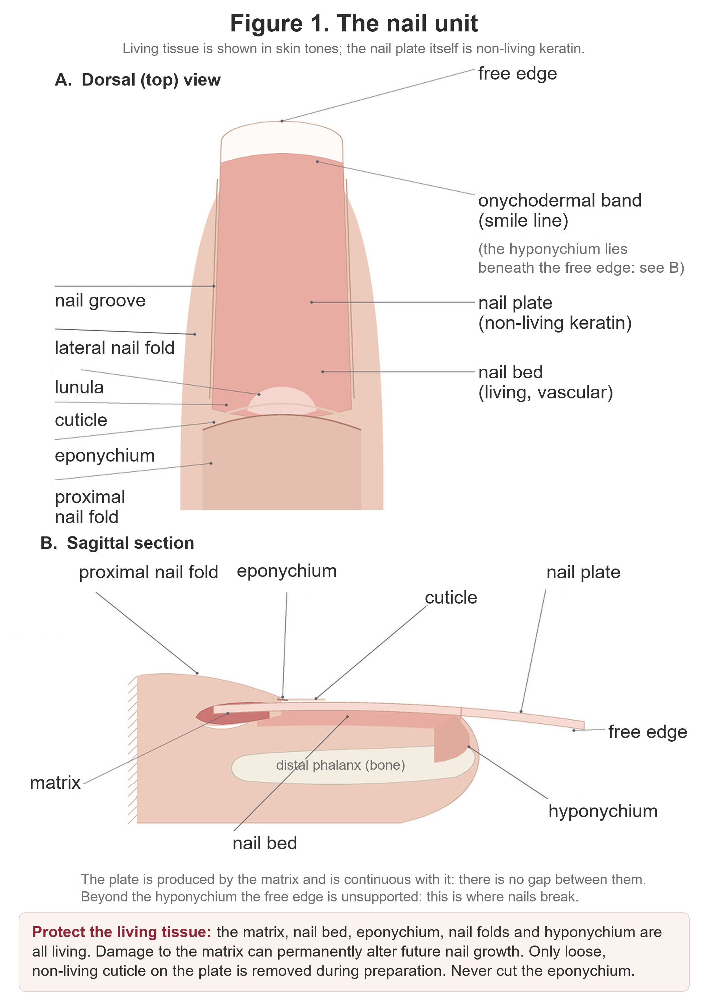
Figure 1. The nail unit. A: dorsal view. B: sagittal section. The matrix produces the nail plate and is continuous with it. The free edge beyond the hyponychium is unsupported.
Original illustration © The Looking Glass Beauty School, 2026.

Structures and functions
Structure | Function and professional relevance
Matrix | Living growth tissue beneath the proximal nail fold. Matrix cells divide, flatten and keratinise to form most of the nail plate. Significant injury can alter future nail growth; the matrix must never be deliberately filed, cut or probed.
Nail plate | The visible, hard but flexible keratin structure. It contains no blood vessels or nerves. Its layers can be thinned or delaminated by over-filing, peeling product, trauma and repeated dehydration.
Nail bed | Living, vascular tissue beneath the plate that supports and anchors it as it advances. It contributes to the pink appearance of a healthy attached nail. Separation of plate from bed is onycholysis.
Proximal nail fold / proximal nail wall | Living skin at the base of the nail that protects the emerging plate and matrix. It is not 'dead cuticle' and should not be aggressively pushed back or cut.
Lateral nail folds / nail walls | Living skin along each side of the plate. They protect the nail unit and guide the plate. Filing into these folds can cause pain, breaks in the barrier and infection risk.
Cuticle | Thin non-living tissue shed from the underside of the proximal nail fold and carried onto the plate. Only loose or adhered non-living tissue is gently removed during preparation.
Eponychium | Living tissue associated with the proximal nail fold and protective seal. It is often incorrectly called the cuticle. Do not cut it simply to create a visually 'clean' margin.
Lunula | The visible pale crescent of the distal matrix on some nails, most obvious on thumbs. Its visibility varies and absence from view is not automatically abnormal.
Hyponychium | Living tissue beneath the free edge where the nail bed ends. It forms a protective barrier. Do not dig under, cut or separate it while cleaning or shortening the nail.
Free edge | The part of the plate extending beyond the fingertip. It can be shortened and shaped while the finger and sidewalls are supported.
Nail grooves | Channels at the sides in which the plate advances. Product should not be flooded into these areas.
Onychodermal band | The transition between nail bed and hyponychium, sometimes visible as a narrow colour change beneath the plate. It is part of the distal protective seal.

How the nail grows
New nail-plate cells are produced in the matrix. As cells mature they flatten, lose their nuclei, fill with keratin and are pushed distally over the nail bed. A fingernail commonly grows at around 3 mm per month, although the rate varies between people, fingers and seasons. A completely new fingernail may take roughly four to six months to grow from matrix to free edge. Growth may be slower with age, illness, impaired circulation, nutritional deficiency, some medication and significant trauma. Use a range and explain variation rather than promising an exact regrowth date.

Factors that can influence nail appearance and growth
- Local trauma: crushing, repeated tapping, biting, picking, over-filing and forced product removal can affect the plate, bed or matrix.
- Water and chemicals: repeated wetting/drying, detergents and solvents can contribute to brittleness and delamination.
- General health: illness, fever, inflammatory skin disease, anaemia and other conditions may be associated with nail changes, but a nail professional must not diagnose the cause.
- Medication and medical treatment: some medicines and treatments can change growth, colour, thickness or fragility. Record only information relevant to treatment safety and refer when the change is new or unexplained.
- Age and individual variation: ridging, thickness and growth rate vary. A difference is not automatically disease, but a sudden or marked change should not be concealed.
- Technique and equipment: over-filing with a hand file or an electric file, heat from friction, a bit edge dug into the plate, forced product removal and excessive enhancement length can thin, groove or separate the plate and damage the matrix beneath the fold.

Protecting the natural nail
- Use the least abrasive preparation that does the job: the finest grit, the lowest speed, the lightest pressure. Remove shine, never nail. Do not 'etch' grooves into the plate.
- Support the finger and use light, controlled strokes. Stop if the client reports heat, pain or tenderness.
- Keep every bit away from living skin. Only a rounded safety bit at low speed works in the cuticle area, and it works on the plate beside the fold, not on the fold. Nothing with an edge or a point goes near the eponychium or the hyponychium.
- Never use the electric file to lever, dig or 'clean out' under a lifted edge or a separated plate. Preventing mechanical trauma is part of the service and part of aftercare.
- If the nail plate is visibly thin, sore, grooved or over-filed, the electric file does not touch it: use hand tools, keep the service minimal, and allow recovery rather than hiding the damage.

Chapter 4 — Nail diseases, disorders and recognition
Observe, record, decide and refer — never diagnose
A disease is a pathological process such as infection or inflammatory illness. A disorder or nail change may be traumatic, congenital, behavioural or associated with general health. The categories overlap, and appearance alone is not enough to diagnose. A nail professional should describe what is seen, ask relevant questions, decide whether treatment is safe and refer when uncertain.
FOUR-STEP DECISION — OBSERVE the nail and surrounding skin. ASK when it began, whether it hurts or itches, and whether it is changing. DECIDE whether to proceed, adapt or postpone within your competence and insurance. RECORD the decision and REFER when there is infection, inflammation, unexplained change, pain, broken skin or uncertainty.

Core diseases and disorders
Condition or change | What may be observed | Professional action
Onychomycosis (fungal nail infection) | Thickened, brittle, crumbly or discoloured nail; debris; lifting may occur. Psoriasis and trauma can look similar, so visual inspection is not a diagnosis. | No electric file and no coating. The dust from a filed infected nail spreads the organism to the desk, the extraction filter and the next client. Advise pharmacist, GP or podiatry assessment; use single-use items; treatment is medical, not a salon service.
Onycholysis | Separation of the nail plate from the bed, often beginning distally. The detached area appears white, grey or discoloured. Causes include trauma, psoriasis, fungal infection, irritants and other conditions. | Do not file, buff or coat active, extensive, painful, discoloured or unexplained separation, and never work a bit under the lifted plate. Keep the area dry and refer. Where a stable, diagnosed residual change is treated with insurer approval, the electric file stays off that nail: hand tools only.
Onychophagy (nail biting) | Short, irregular free edge; surrounding skin may be picked, sore or broken. Severity varies. | Where the surrounding skin is intact, a cautious service is possible: the safety bit stays on the plate, away from the sore, bitten folds, and the plate is often thin, so de-shining is by hand buffer. Refuse where the skin is broken, sore or infected.
Nail psoriasis | Pitting, thickening, colour change, crumbling, onycholysis or oil-drop/salmon patches may occur. It is inflammatory and not contagious. | Do not diagnose. Avoid treatment during an active painful flare, where skin is broken, or where the presentation is uncertain. A pitted or crumbling plate is not a surface for an electric file; stable diagnosed psoriasis may sometimes be treated with medical/insurer guidance, hand tools and gentle technique.
Paronychia | Red, swollen, warm and tender nail fold; pus may be present. It may be acute bacterial infection or chronic inflammation associated with repeated wet work. | Refuse treatment. Do not drain, cut, massage, file or cover the area; a bit near an inflamed fold is an injury waiting to happen. Advise prompt pharmacy/medical assessment, especially if pain, pus, spreading redness or systemic illness is present.
True pterygium | Scar-like adhesion or abnormal forward growth of tissue involving the nail unit. Dorsal pterygium can split or narrow the plate; pterygium inversum affects tissue beneath the free edge. | Do not confuse true pterygium with ordinary cuticle. Do not cut, push or file adherent living tissue, and never use a bit to 'clear' it. Refer for medical assessment before any cosmetic service.
Onychogryphosis (thick dystrophic nail) | Marked thickening, curvature and distortion of the nail, which may trap debris or be difficult to cut. It usually affects toenails and is often associated with pressure, age or neglect. | Out of scope. Do not attempt to reduce a thickened, distorted nail with an electric file unless separately qualified and insured to do so; the heat and the depth of filing needed are a podiatry matter. Refer to a podiatrist/medical professional, especially where diabetes, poor circulation, pain or infection risk is present.
Brittle or splitting nails (onychoschizia/onychorrhexis) | Peeling layers, transverse splitting or longitudinal ridges/splits. Repeated water/chemical exposure and trauma can contribute; systemic causes are also possible. | Mild stable brittleness with intact skin: hand tools on the natural nail; the electric file only on product that is already on the nail, at low speed, leaving a thin layer. New, severe, painful or multiple-nail changes require referral. A peeling plate is thinner than it looks.
Koilonychia (spoon nails) | A concave or spoon-shaped plate. It can be congenital, traumatic or associated with health conditions such as iron deficiency. | If new or unexplained, refer. Do not use product or filing to disguise a possible health sign. If longstanding, medically reviewed and intact, treatment may be adapted within insurer conditions; the concave plate is often thin at its centre, so the electric file stays off it.
Duckbill / flared nail shape | The free edge widens or fans outward. This may be the natural growth pattern or result from previous enhancement architecture. | No issue for the electric file in itself. Where flaring follows previous enhancement architecture, reduce the old product evenly and let the natural shape show before planning the next service; do not thin the sidewalls to disguise it.
Leukonychia (white spots) | Small opaque white marks commonly follow minor matrix trauma and grow out with the plate. Widespread, powdery or changing white areas can have other causes. | A few stable trauma-related spots on an otherwise healthy nail are not a contraindication. Do not diagnose. Refer powdery, spreading, lifting, painful or unexplained changes; and note that a white, powdery area on the plate after a previous service may be friction damage, which the electric file must not touch.
Beau's lines | Transverse depressions caused by temporary interruption of nail growth. They may follow illness, injury or other stress. | If shallow, growing out and the nail is healthy, a gentle cosmetic service may be possible; the plate is thinner in the groove, so no electric file across it. New, deep, multiple or unexplained lines should be referred.
Splinter haemorrhage | Fine red-brown or black lines beneath the plate, often from minor trauma but sometimes associated with health conditions. | If clearly linked to minor trauma and growing out, record and monitor. Multiple, recurrent or unexplained marks require medical advice. Never cover a suspicious dark streak without referral.
Subungual melanoma warning sign | A new or changing dark longitudinal band, pigment spreading onto surrounding skin, nail destruction, bleeding or a persistent unexplained lesion. | Do not cover. Urgently advise GP assessment. Nail melanoma is uncommon, but delay caused by cosmetic concealment is unacceptable.

Recognising what you are looking at
The photographs below show presentations you may meet at the consultation. Use them to recognise and describe what you see — never to diagnose. Where a nail does not look like any of these, that is itself a reason to pause and refer.
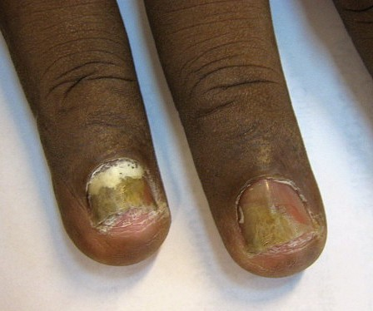
Figure 2. Onychomycosis affecting two fingernails. Yellow-brown discolouration, thickening, crumbling of the plate and separation at the free edge. No electric file and no coating — the dust would spread the organism, and treatment is medical, not a salon service.
Photograph © Grook Da Oger, via Wikimedia Commons, CC BY-SA 3.0.
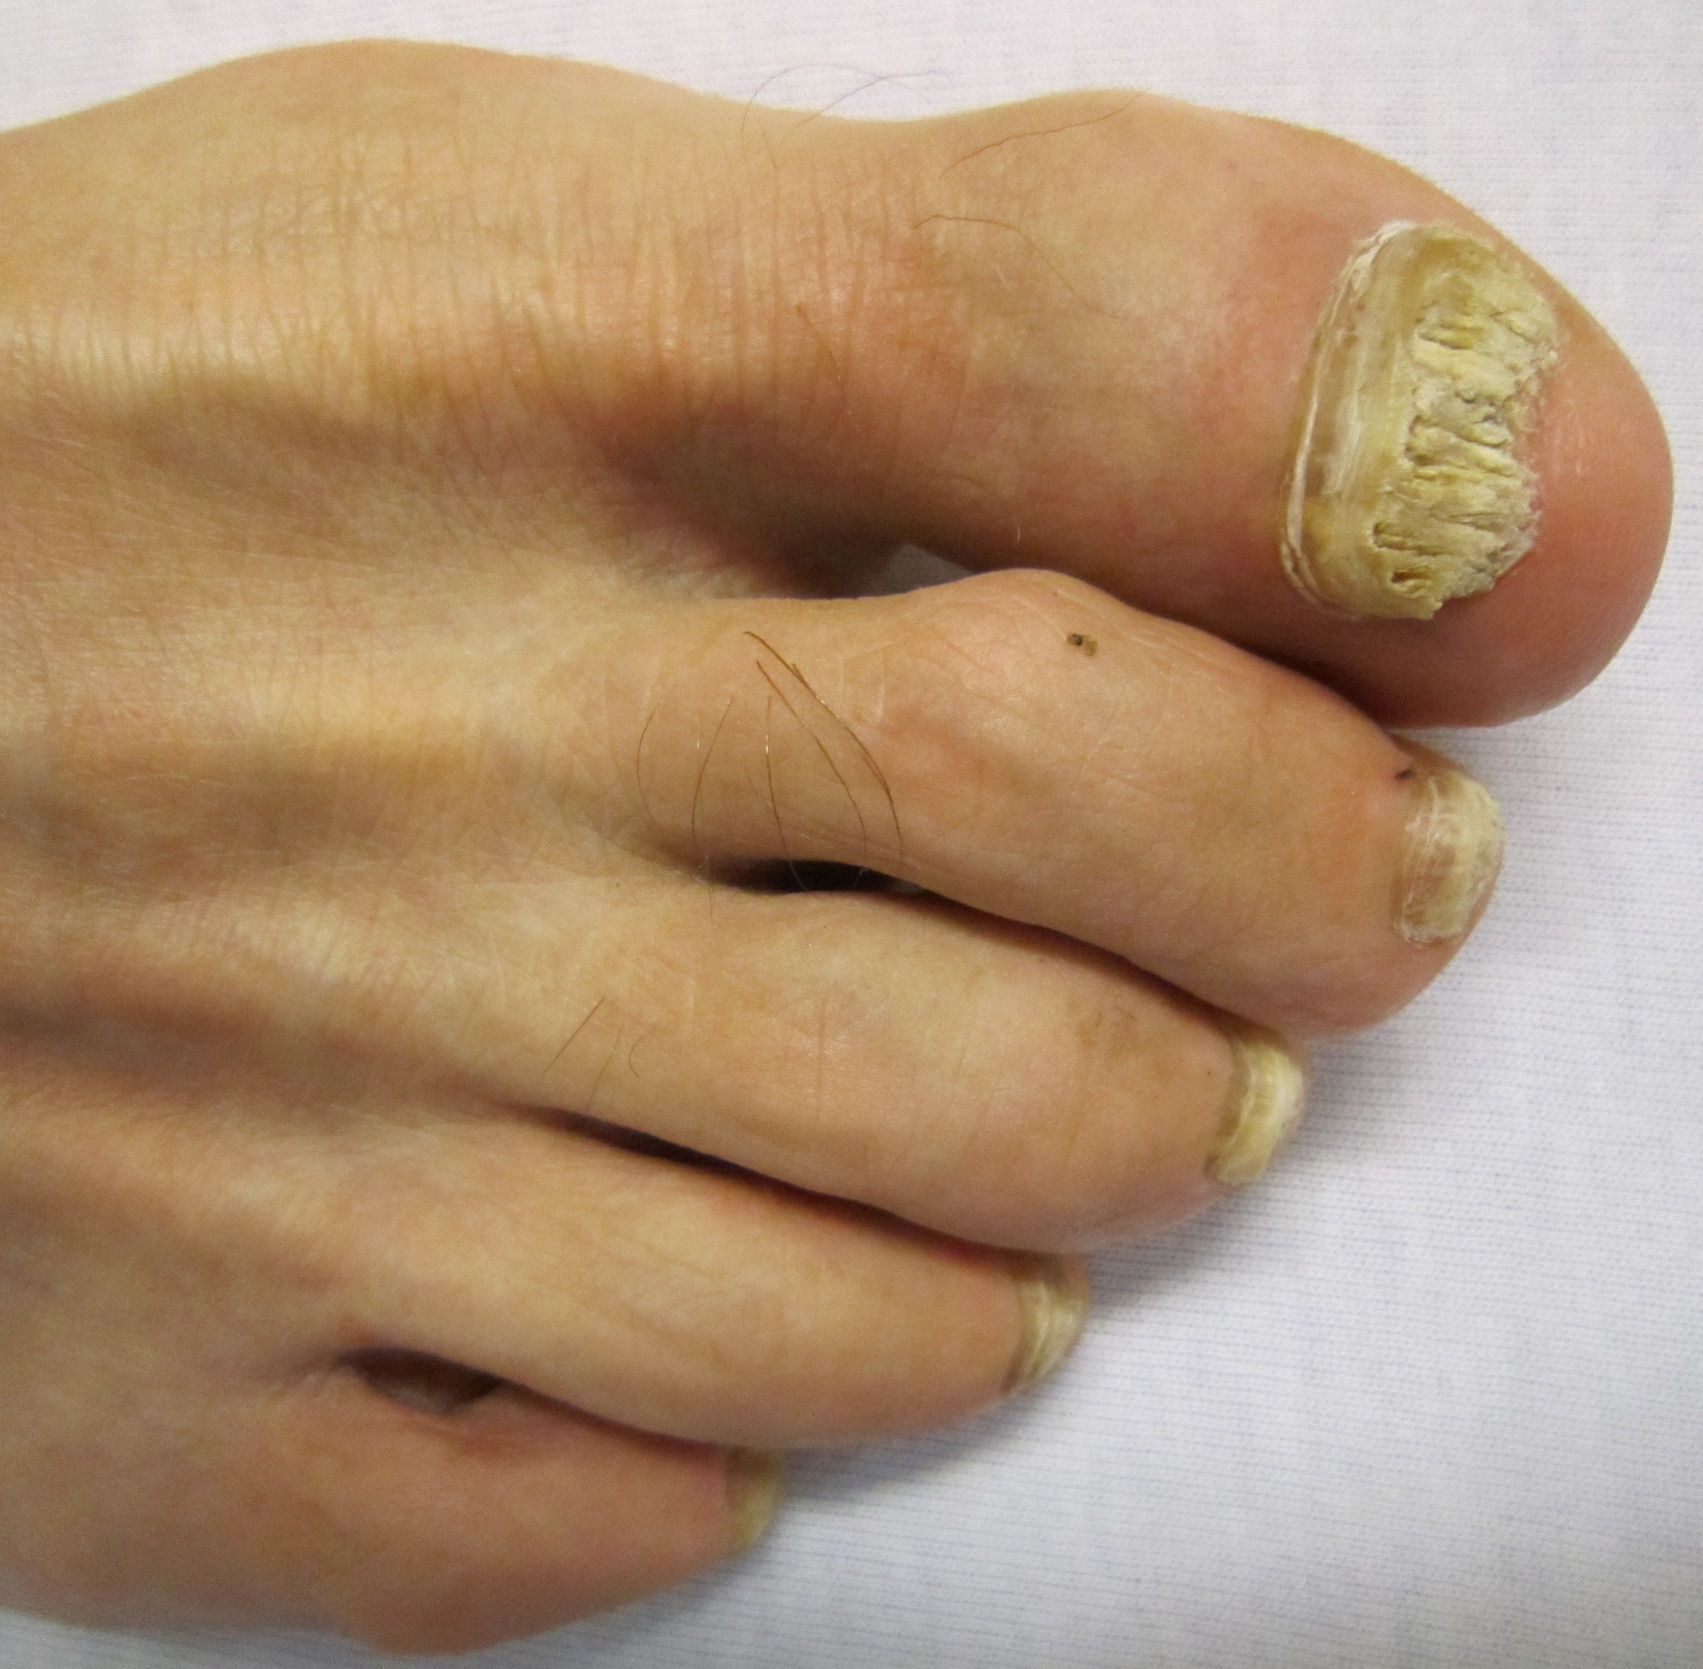
Figure 3. Onychomycosis more commonly affects toenails, as here: marked thickening, yellow-white crumbling and debris beneath the plate. Psoriasis and repeated trauma can look similar — visual inspection is never a diagnosis.
Photograph © James Heilman, MD, via Wikimedia Commons, CC BY-SA 3.0.
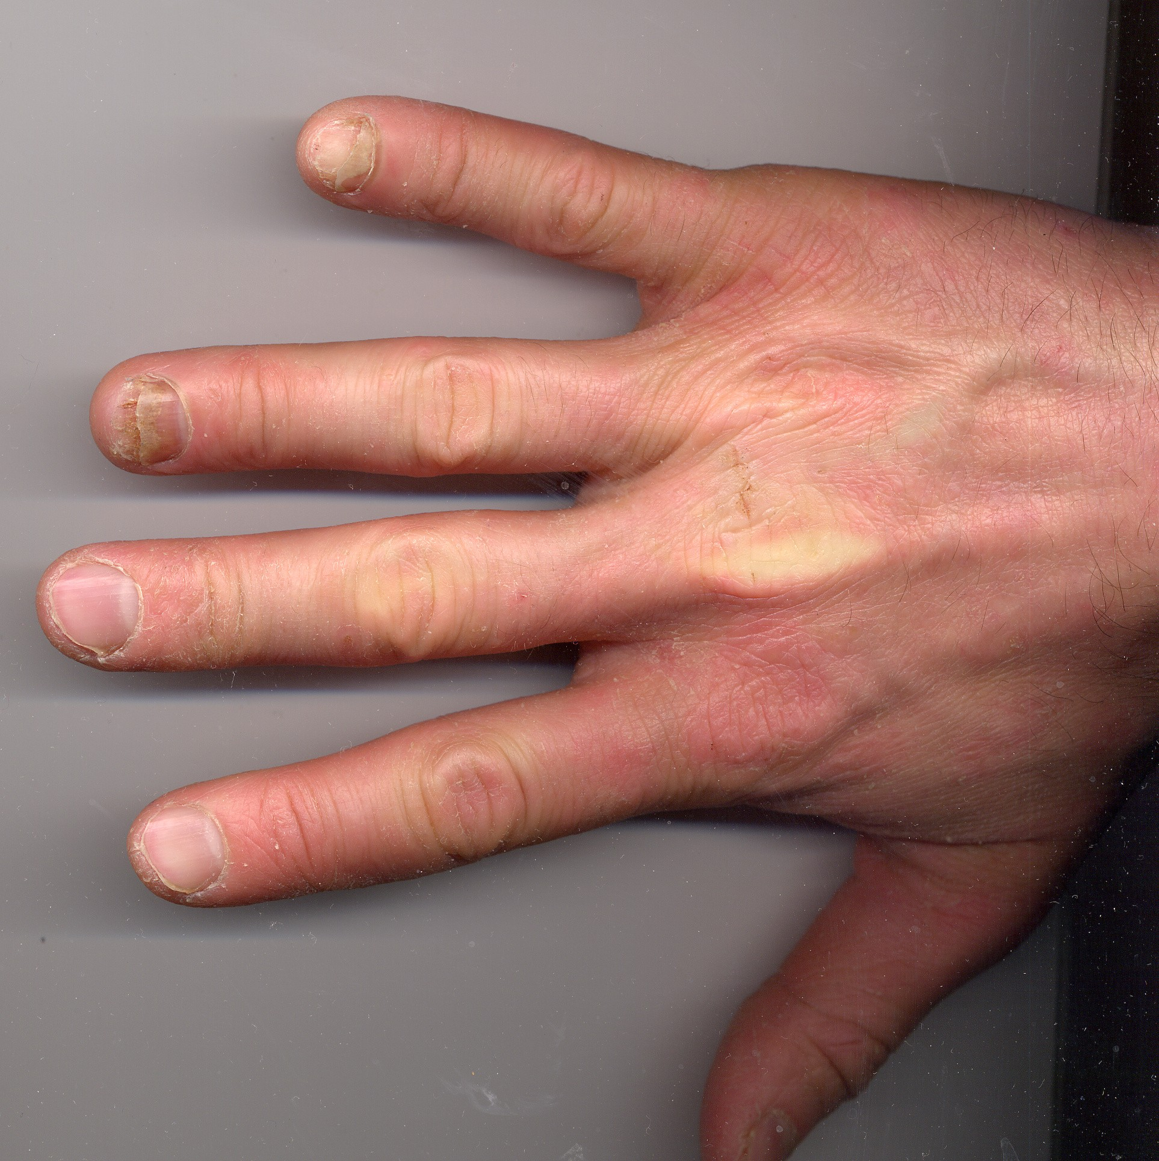
Figure 4. Onycholysis of the ring and little fingernails. The plate has separated from the bed beginning at the free edge, and the detached area appears pale and discoloured. Do not cover active, extensive or unexplained separation.
Photograph © CopperKettle, via Wikimedia Commons, CC BY-SA 3.0.
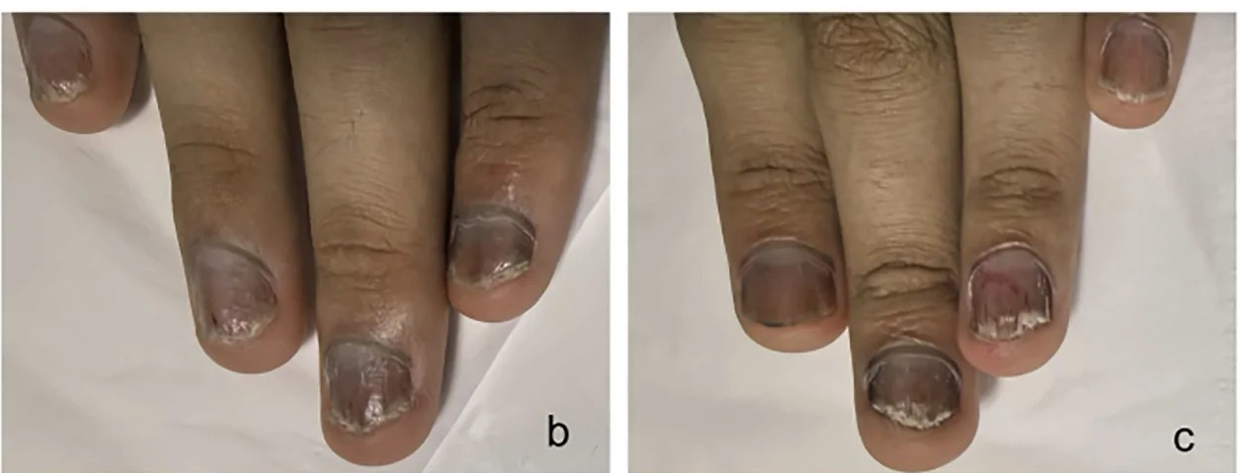
Figure 5. Nail psoriasis. Crumbling of the plate, subungual debris, colour change and separation at the free edge. Psoriasis is inflammatory and not contagious, but it can look very like fungal infection — which is exactly why appearance alone is never a diagnosis. Avoid treatment during an active flare, where skin is broken, or where the presentation is uncertain.
Photograph © Huang Y & Wen S, Frontiers in Immunology (2026), doi:10.3389/fimmu.2026.1941127, CC BY 4.0, cropped. Paediatric patient.
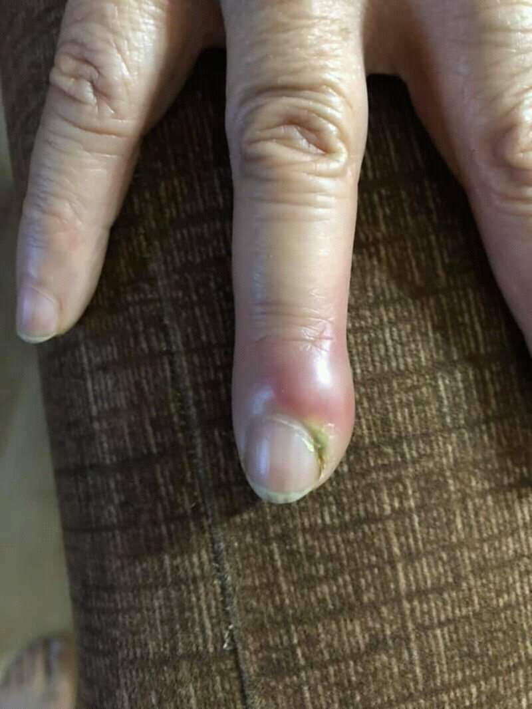
Figure 6. Acute paronychia. The nail fold is swollen, red and tender, with pus present. Refuse treatment. Do not drain, cut, massage or cover the area; advise prompt pharmacy or medical assessment.
Photograph © Mohammad2018, via Wikimedia Commons, CC BY-SA 4.0.
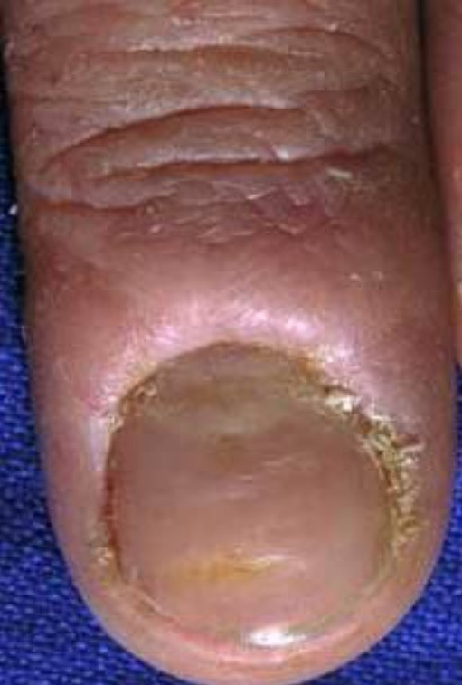
Figure 7. Chronic paronychia. The cuticle seal is lost, the proximal nail fold is thickened and bolstered, and the plate shows ridging and colour change. Commonly associated with repeated wet work.
Photograph © Daifallah M. Al Aboud, M.D., via Wikimedia Commons, CC BY 4.0.
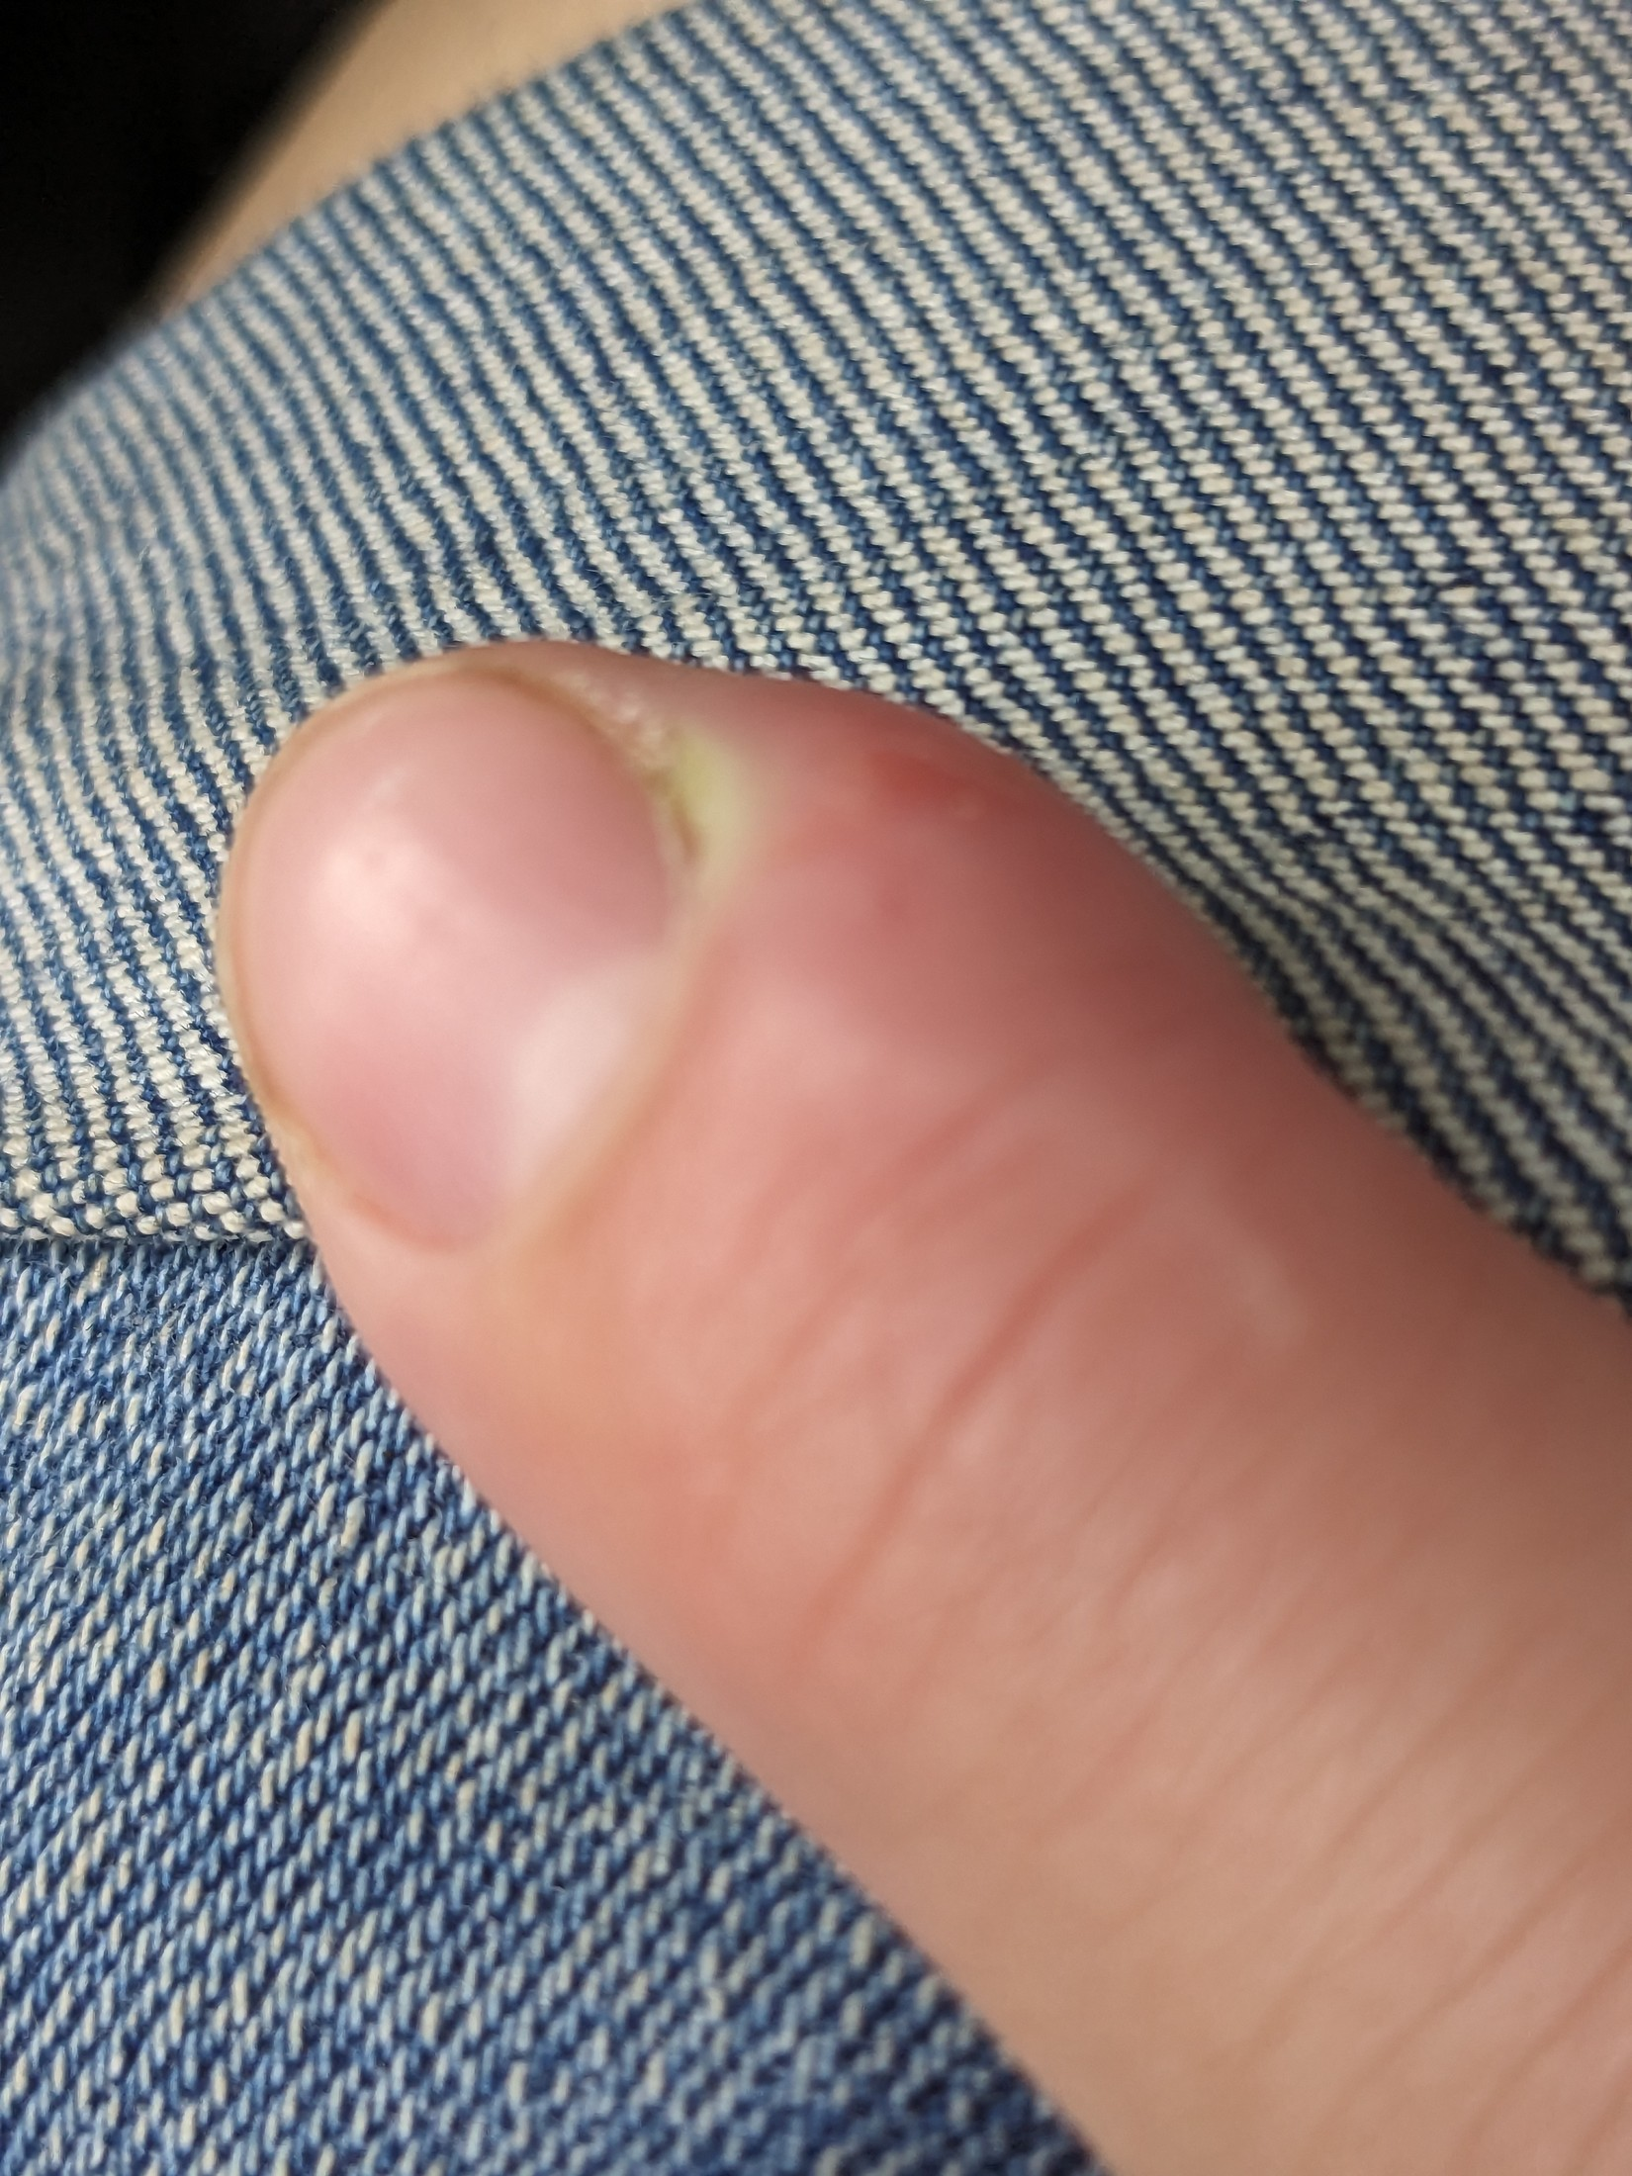
Figure 8. Early paronychia. Localised swelling and a small pus point at the nail fold, with the skin barrier already broken. Even at this stage the service is refused and the client referred.
Photograph © Hannah Clover, via Wikimedia Commons, CC BY 4.0.
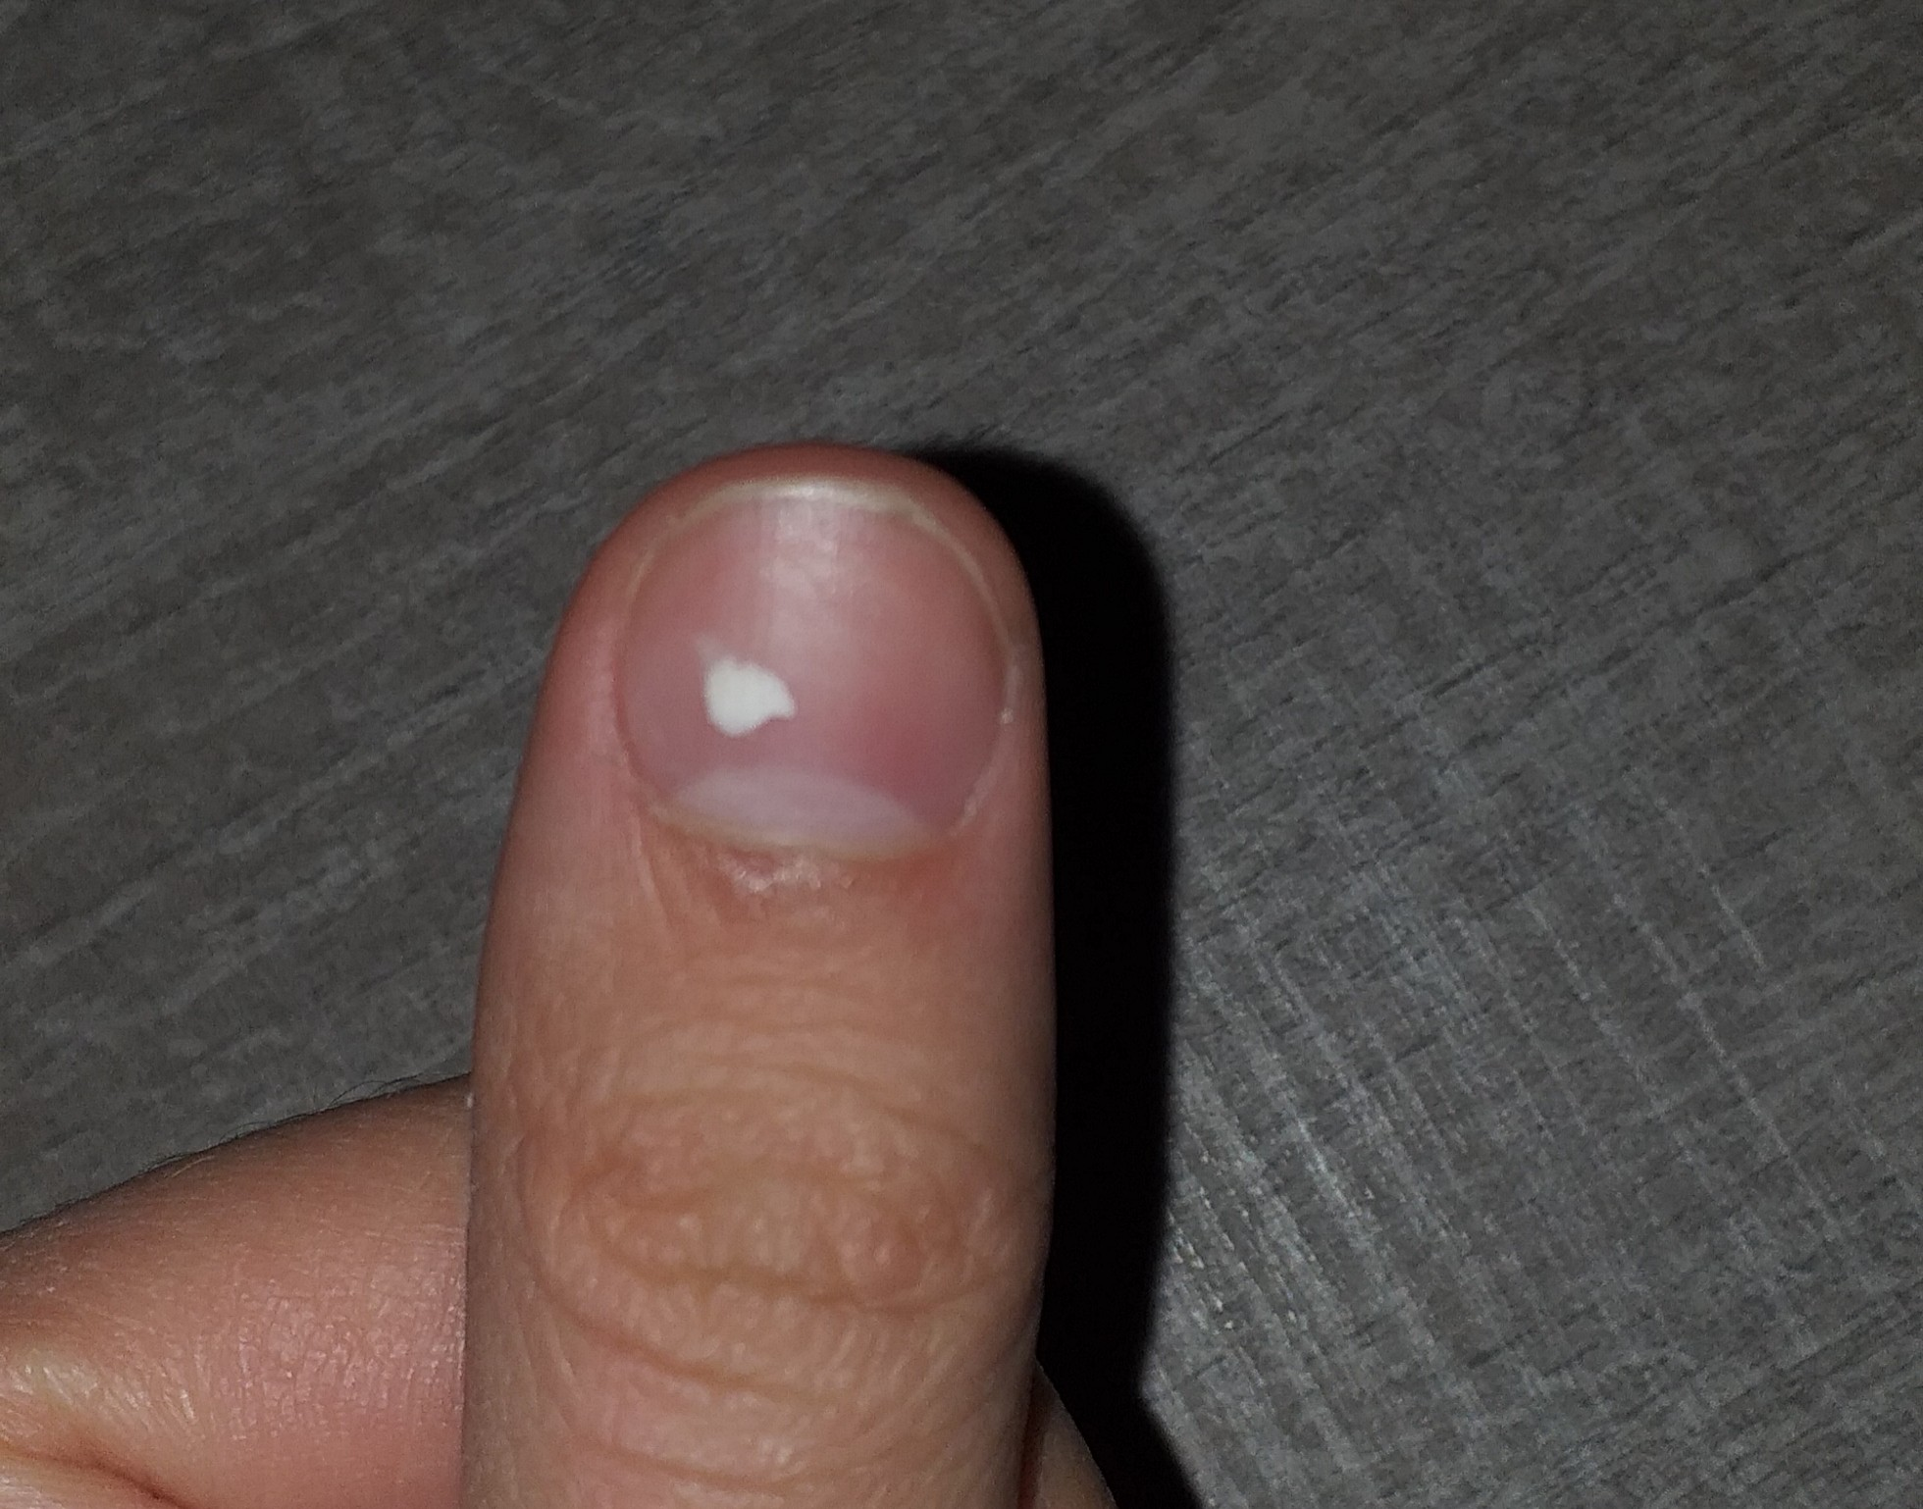
Figure 9. Leukonychia punctata. A single opaque white spot following minor matrix trauma, which grows out with the plate. A few stable spots on an otherwise healthy nail can usually be coated — but do not diagnose.
Photograph © BrotherLongLegs, via Wikimedia Commons, CC BY-SA 4.0.
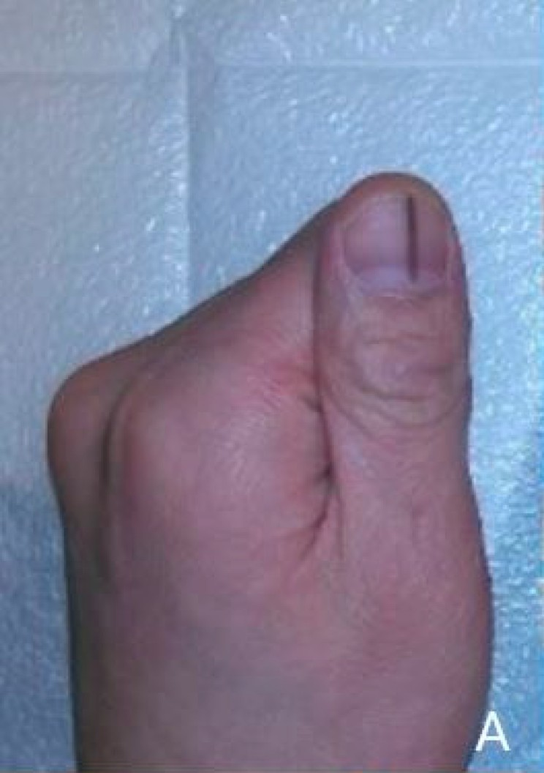
Figure 10. Longitudinal melanonychia — a dark band running the length of the plate. DO NOT COVER. A new or changing band, pigment spreading onto the surrounding skin, nail destruction or bleeding requires urgent GP assessment.
Photograph © Seungjun Lee & Seokchan Eun, via Wikimedia Commons, CC BY 4.0.

Green nail and suspected bacterial infection
Green, green-black or yellow-green discolouration beneath a lifted coating is commonly associated with colonisation by Pseudomonas bacteria in a moist space, although colour alone cannot confirm the organism. It is not correctly described as 'green fungus'. The professional response is not to hide the stain or prescribe a home chemical remedy.
- Stop the service and do not apply fresh product over the discolouration.
- If an existing enhancement can be removed without cutting skin or over-filing, remove it using the correct product method and within competence. The electric file may reduce the bulk of the product only where the plate beneath is sound; it never touches the discoloured or separated area. If safe removal is uncertain, refer to a suitably qualified professional.
- Keep the nail clean and dry. Do not dig under separated plate, buff away colour or use household bleach, neat vinegar, antibiotics or another treatment unless directed by a healthcare professional.
- Advise the client to seek medical or pharmacy advice, particularly where there is pain, swelling, pus, spreading redness, diabetes, reduced immunity or persistent discolouration.
- Discard contaminated single-use items, quarantine reusable tools and complete the full cleaning/disinfection or validated sterilisation process required by the risk assessment. Record the product, affected nails, observations, action and referral.
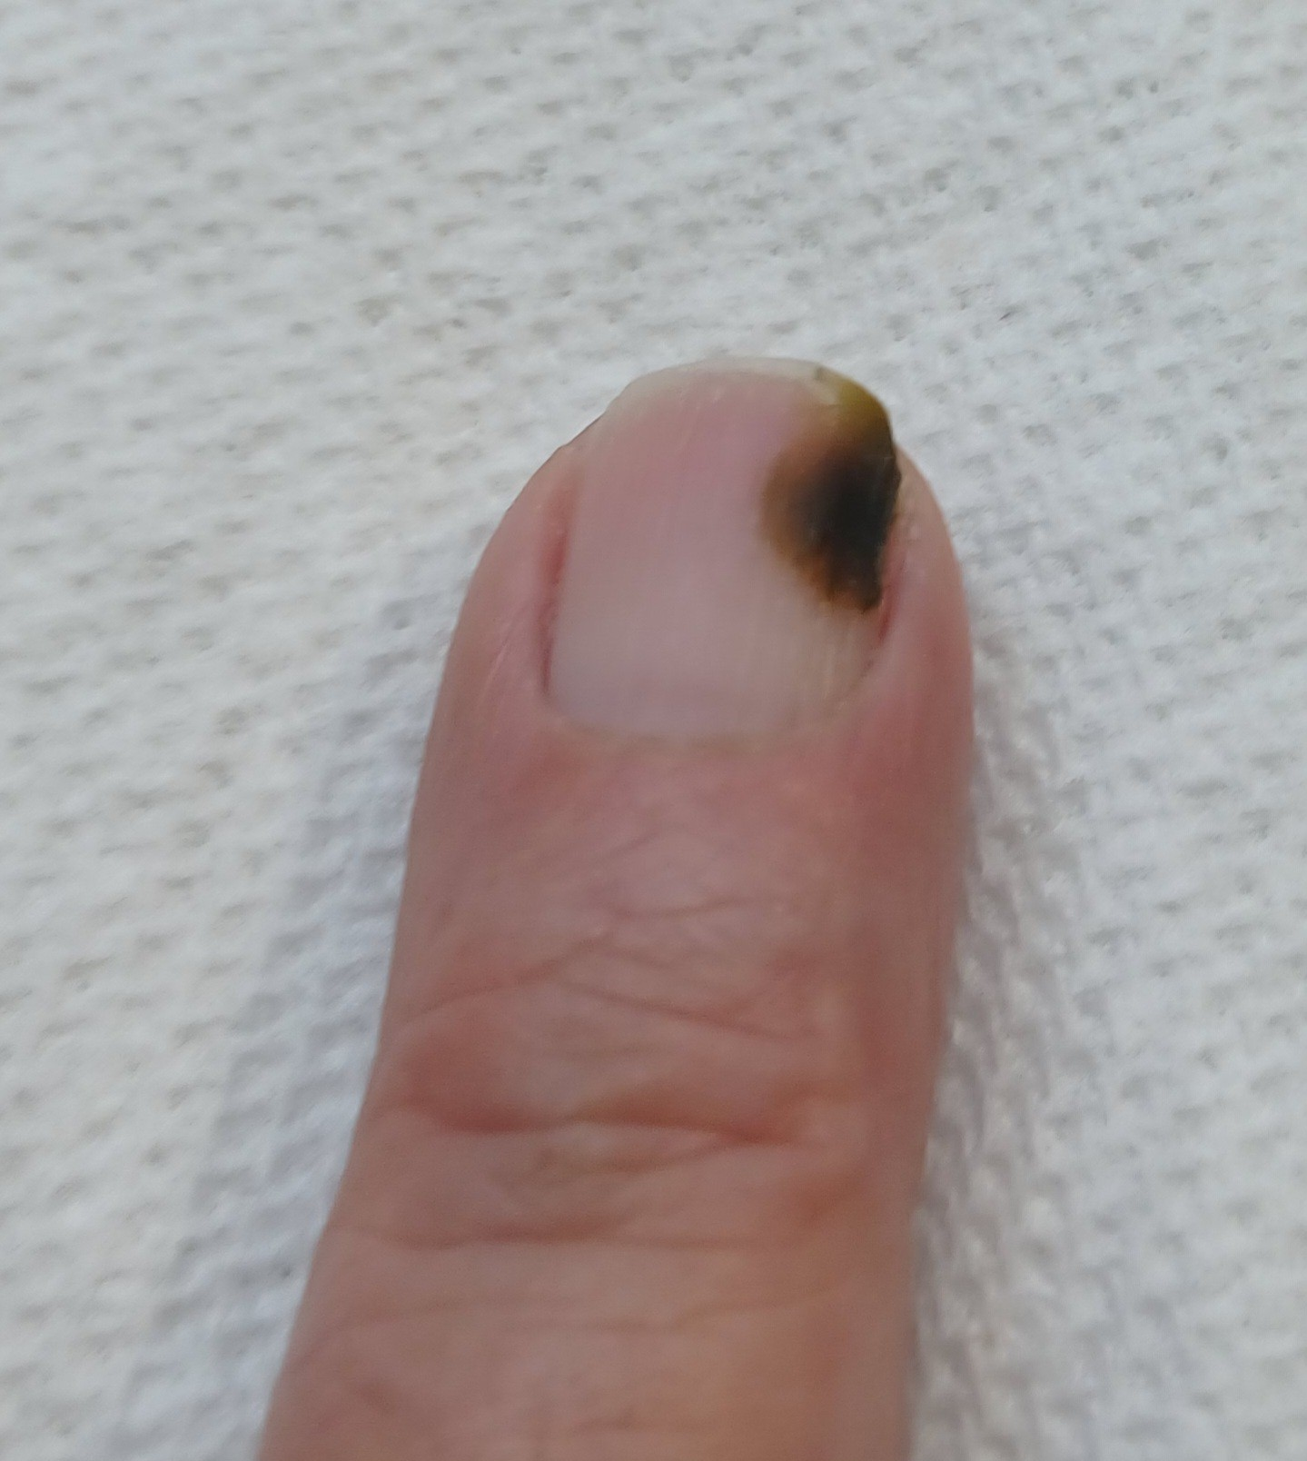
Figure 11. Green nail (chloronychia). Green-black discolouration associated with bacterial colonisation in a moist space. It is not 'green fungus'. Do not apply fresh product over the discolouration.
Photograph by Ekem, via Wikimedia Commons, CC0 1.0 (public domain dedication).
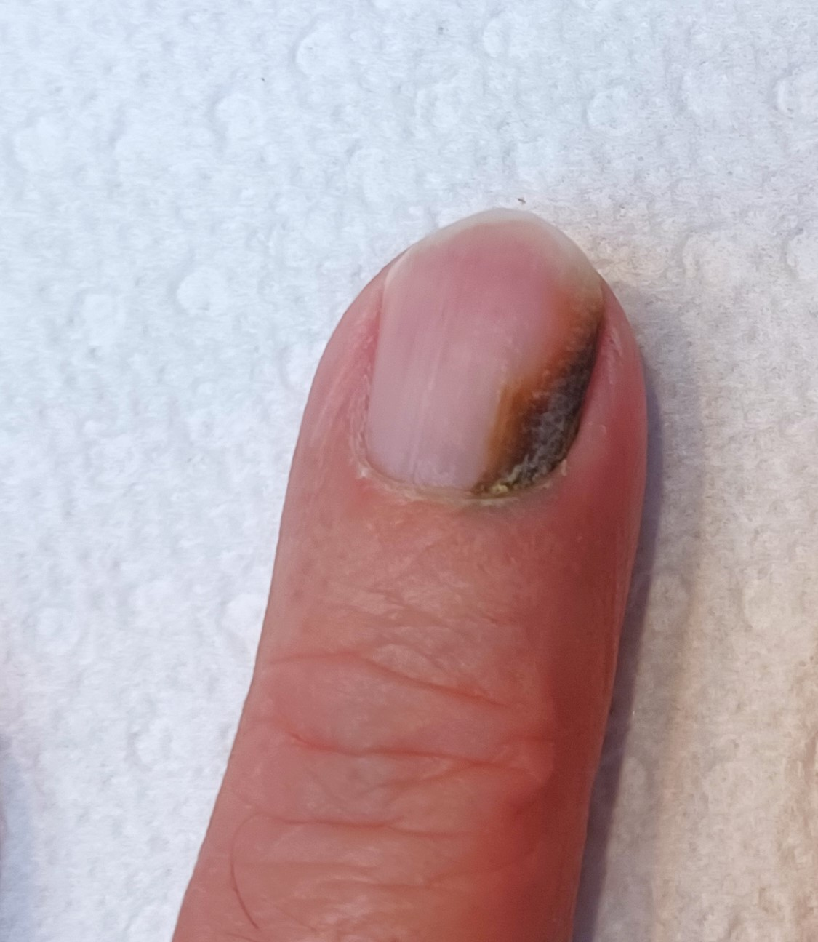
Figure 12. Green nail with associated onycholysis. The discolouration sits beneath a separated area of plate. Do not buff away the colour or use household remedies; keep dry, refer, and decontaminate tools.
Photograph by Ekem, via Wikimedia Commons, CC0 1.0 (public domain dedication).

Contraindications that are not diagnoses
The following findings or circumstances can prevent or restrict an electric-file service even when no named nail disease has been diagnosed:
- Known or suspected acrylate/methacrylate allergy, or a previous reaction to gel, acrylic, nail glue or filing dust: the dust from cured product is a sensitiser, and the client's own history decides whether the product can be reduced by machine, by hand, or must be referred back to whoever applied it.
- Active eczema, dermatitis, psoriasis flare or unexplained rash on the hands, fingers or treatment area.
- Cuts, abrasions, bleeding, burns, blisters, swelling, heat, tenderness or recent trauma around the nail.
- A wart or other contagious lesion where the service could touch or spread it.
- Recent surgery, severe nail damage, significant plate thinning, rings of fire from a previous service, a plate that flexes or looks translucent, or pain on light pressure. A thin plate conducts heat to the bed in seconds.
- A new, changing, unexplained or suspicious colour/shape change.
- A client who cannot keep the hand still, cannot feel heat in the fingertips (for example with neuropathy or after some treatments) or cannot tell you at once when a nail feels warm, or who cannot follow aftercare, communicate discomfort or give informed consent. Reduced sensation means hand tools on the natural nail and extra heat checks on product.
- Any medical condition, treatment or medication for which the insurer or manufacturer requires medical advice, adaptation or refusal. Diabetes and pregnancy are not automatic universal bans; assess individually, avoid injury and follow insurer/product guidance.
DO NOT USE GP LETTERS AS A BLANKET TRANSFER OF RESPONSIBILITY — A doctor's note does not make an unsuitable treatment safe and does not override the professional's competence, product instructions or insurance. Ask only for relevant confirmation, make your own treatment decision and record the rationale.

Chapter 5 — Consultation, treatment planning and consent
A safe service begins before the product is opened

Purpose of the consultation
A consultation is a structured two-way conversation and assessment. It establishes what the client wants, whether the treatment is appropriate, how it should be adapted and whether the client understands costs, maintenance, limitations and risks. A signed form supports the process but is not a substitute for observation, professional judgement or dialogue.

The consultation sequence
- Create privacy and explain why relevant questions are being asked. Confirm the client's identity, age and preferred communication needs.
- Clarify what the client wants from this visit: a removal, an infill, a natural-nail preparation before a new coating, a reshape, or a toenail product removal; and what is on the nails now, who applied it and when.
- Ask about previous nail services, how the product has worn, lifting, how it has been removed before and by whom, any electric-file work in the past and how it felt, reactions, allergies, and whether any nails are painful, thin or changing.
- Collect only health and medication information that is relevant to treatment safety. Explain that health data is sensitive and how it will be protected.
- Visually and manually assess the nail plate, free edge, folds, surrounding skin and each hand. Compare nails; do not conceal suspicious findings.
- Identify contraindications and decide to proceed, adapt, postpone or refuse. Explain the reason respectfully without diagnosing.
- Agree a realistic treatment plan: what the electric file will do and what hand tools will do, which bits and speeds, how long it will take, the price, what the nails will look like afterwards, and the aftercare. Tell the client what warmth feels like and agree a stop signal.
- Explain foreseeable risks including warmth from friction, temporary dryness, dust, a nail that feels sensitive after removal, and the harm from over-filing or forced removal; and explain that the client can ask you to stop at any moment.
- Obtain treatment consent. Obtain separate, optional consent for identifiable photographs or marketing; refusal of marketing consent must not prevent treatment.
- Record what was on the nail and its removal category, the machine, the bits, grits and speeds used, any heat reported and what you did, observations, adaptations and aftercare. Update the record at every appointment.

Treatment planning
A treatment plan converts consultation findings into a safe, individual service. It should be specific enough that another competent professional can understand what was agreed and what happened.
Planning area | What to decide and record
Client goal | Removal, infill preparation, natural-nail preparation, reshape or toenail product removal; what the nails should look like afterwards; time available
Nail condition | Plate thickness and flexibility, any grooves or white areas from previous filing, free-edge condition, skin integrity, sensation in the fingertips, relevant variations and the contraindication decision
Lifestyle | Work, handwashing/wet work, chemicals, sport, gardening, caring, musical instruments, habitual picking and time available for maintenance
System | What is on the nail and its removal category; which bits, grits and speeds; where hand tools are used instead of the electric file, and why
Adaptation | Hand tools only on a thin or sensitive plate, lower speed and finer grit, more frequent lifting and heat checks, one nail excluded, extra time for a thick set, or the service postponed
Service variation | Reduce for an infill, full removal, natural-nail preparation only, shaping and finishing of cured product, toenail product removal; what is out of scope and who to refer to
Risk and consent | Benefits, limitations, warmth and the stop signal, dust, aftercare, cost and separate photo consent
Review | Expected maintenance/removal date, what the client should report (tenderness, grooves, colour change), and outcome at the next visit

Consent is informed and ongoing
- The client must understand what will be done, material risks, alternatives and the right to stop. A signature does not remove the duty of care.
- Check consent again if the plan changes, discomfort occurs or another product is proposed.
- Do not use coercive wording such as 'I accept all responsibility'. A professional remains responsible for acting competently.
- For case-study photographs, obtain model consent for the educational purpose and specify who will see the images, how long they will be kept and whether the face/identity will be excluded.
- If consent cannot be freely and clearly given, do not treat.

Consultation scenario
LEARNER ACTIVITY — A client books 'an infill' and arrives with a thick, lifted acrylic set applied elsewhere; she does not know the brand, two nails have grooves near the cuticle from her last 'drill', and she says the last salon 'burned' her. Identify the immediate contraindications, what the grooves tell you, the questions you would ask, what the electric file may and may not do on these nails, and a realistic plan. Record your answer before discussing it with the group.

Chapter 6 — The machine: parts, controls and set-up
Know every part before it touches a nail
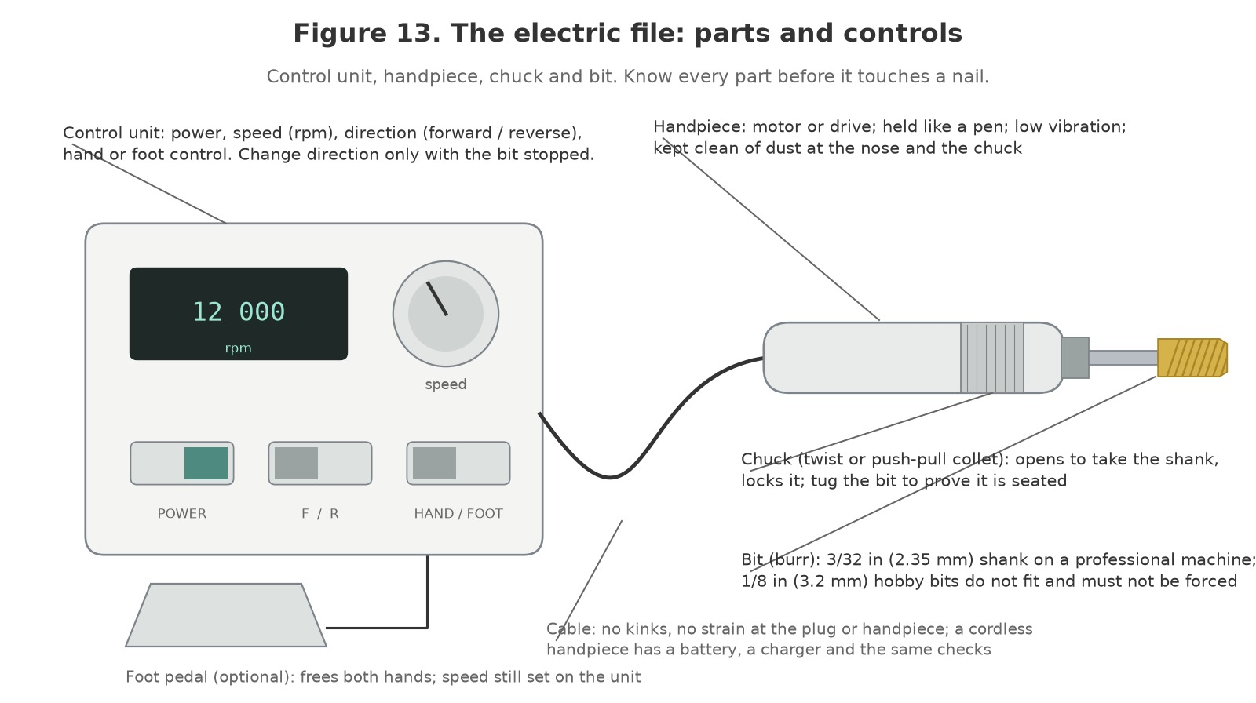
Figure 13. The electric file: parts and controls. Control unit with power, speed, direction and hand/foot switches; the cable; the handpiece with its chuck; a bit on a 3/32-inch shank; the optional foot pedal.
Original illustration © The Looking Glass Beauty School, 2026.

The parts
Item | Purpose and safe use
Control unit | Sets the speed, shown in rpm on a dial or a display, and the direction (forward or reverse). Some units add a hand/foot switch and a torque setting. Keep it on a dry, stable surface away from the extraction outlet and liquids; switches wiped, never sprayed.
Handpiece | Holds the motor (or, on older machines, a cable drive) and the chuck. Held like a pen with a light grip. It warms in use; a handpiece that is hot to hold, noisy or vibrating is stopped and rested, then checked. Cordless handpieces carry a battery and charger and need the same checks.
Chuck | The collet that grips the shank: twist-lock, push-pull or lever. Opened only with the machine off; the bit pushed fully home; closed; then tugged to prove it is seated. Dust in the chuck causes wobble, so it is brushed out daily.
Shank | The 3/32-inch (2.35 mm) shank is the professional standard. Hobby rotary tools take 1/8-inch (3.2 mm) bits; neither fits the other, and a bit forced into the wrong chuck wobbles and can fly out.
Cable and plug | Checked for kinks, cuts, strain at either end and heat marks before every day's use. Routed so it does not drag on the desk edge or across the client. A damaged cable takes the machine out of use.
Foot pedal | Optional. Frees both hands and lets you stop instantly; the speed is still set on the unit. Placed where it cannot be trodden on by accident.
Extraction | Not part of the machine, but it runs whenever the machine does: a desk-mounted or built-in local exhaust unit under the hands, with its filter and bag maintained as the maker says.

Speed and torque
Speed is how fast the bit turns, in revolutions per minute. Torque is the turning force behind it: the machine's ability to keep turning at a set speed when the bit meets resistance. The two are different, and the difference matters at the desk. A machine with little torque slows or stalls when the bit touches product, and the natural response is to press harder; pressure makes heat and grooves. A professional machine keeps its speed under load at low rpm, so the professional can work slowly with a feather touch and let the bit do the cutting. When you try a machine, test it at 5 000 rpm against cured product: if it bogs down, it will teach you to press.
Professional machines commonly run up to 25 000 to 35 000 rpm. Almost all nail work happens between 3 000 and 20 000 rpm, and the highest speeds are used only for the bulk of hard product with a coarse bit and a steady hand. Chapter 8 gives the working ranges by task.

Direction
Every professional machine runs forward (F) and reverse (R). The direction decides which way the bit's surface is moving at the point where it touches the nail, and therefore whether the bit pulls itself smoothly along the sidewall or grabs and skips (Chapter 8 and Figure 17). Most right-handed professionals work in forward and switch to reverse for the far sidewall; most left-handed professionals do the opposite. Change direction only when the bit has stopped: switching under power jolts the hand and shortens the life of the motor.

Set-up and the pre-use check
- Look at the cable, plug, control unit and handpiece: no damage, no heat marks, no exposed parts, nothing loose. A fault takes the machine out of use; it is not 'probably fine'.
- Extraction on, mask on, the client's hand on the rest and the stop signal agreed.
- Machine off. Open the chuck, push the bit fully home to its stop line, close the chuck, and tug the bit. A bit that moves is not seated.
- Set the direction for the hand you are working and the sidewall you will start on. Set the speed low for the task (Chapter 8); you can always go up.
- Run the bit in the air for a second and watch it: a bit that wobbles or buzzes is bent or dirty. Stop; clean the chuck; try another bit. A bent bit is binned, not straightened.
- Bring the client's nail to the bit, not the bit to the nail: the finger held firmly, your hand braced, the bit flat, the lightest contact, moving at once.
- Between bits: machine stopped, chuck opened, bit out and into the used container, next bit seated and tugged. Between nails: brush the dust under the hood. Between hands: check the handpiece for heat and the speed for drift.

Choosing a machine
- Speed range that starts low (1 000 to 2 000 rpm) with real torque at 5 000 rpm, and a display or marked dial you can read without looking away from the nail.
- Forward and reverse, and a hand or foot control.
- The 3/32-inch shank and a chuck that opens and closes without tools.
- A light, slim, low-vibration handpiece that stays cool in a twenty-minute removal; a cord that does not twist the hand.
- UKCA or CE marking, a UK plug, instructions in English, a warranty and a route to service and spare parts (chucks, carbon brushes, handpieces).
- Not a hobby rotary tool, a craft engraver or an unbranded 'nail drill' with a 1/8-inch chuck and no speed display: these are not work equipment for client use, whatever the price.
FILE, NOT DRILL — Say 'electric file' to clients and mean it. The moment a professional thinks of the tool as a drill, the technique follows: pressure, a point, a hole. Everything in this manual is about a surface moving lightly across another surface.

Chapter 7 — Bits: materials, shapes and grits
Shape decides where a bit can go; material and grit decide how fast it cuts

Materials
Material | How it cuts | Best for | Care
Carbide (tungsten carbide) | Flutes cut into the surface shave product off in curls; little heat for the amount removed | Reducing and removing acrylic, hard gel and builder gel; shaping cured product; never the natural nail | Cleans, disinfects and autoclaves (check the maker); lasts months; dulls gradually, then makes heat
Diamond (bonded grit) | Grit particles scratch the surface away; makes fine dust and more heat per pass than carbide | The cuticle area and sidewalls in safety and flame shapes; fine and extra-fine grades for the natural nail's surface; under the free edge | Cleans, disinfects and autoclaves; grit wears and the bit loses its bite, then it rubs and heats
Ceramic | Fluted like carbide; lighter, and conducts heat less readily, so the handpiece and nail stay cooler | The same product work as carbide; useful for long removals | Cleans and disinfects; can chip if dropped; check the maker before autoclaving
Sanding band on a mandrel | Abrasive paper band; coarse to fine; the cheapest cutting surface | Product surfaces; gel polish removal; de-shining the natural nail in the finest grits at the lowest speed | The band is single use; the mandrel is cleaned and disinfected like a metal bit
Silicone and rubber polishers | Fine abrasive in a soft body; smooths and shines | Finishing cured product; smoothing after reduction; never for removing material | Clean and disinfect; replace when glazed or out of round
Stone (ceramic stone, 'cuticle stone') | A porous abrasive stone | Used by some professionals in the cuticle area; porous, hard to decontaminate and not used on this course | If used at all, single client; porous stone cannot be reliably disinfected
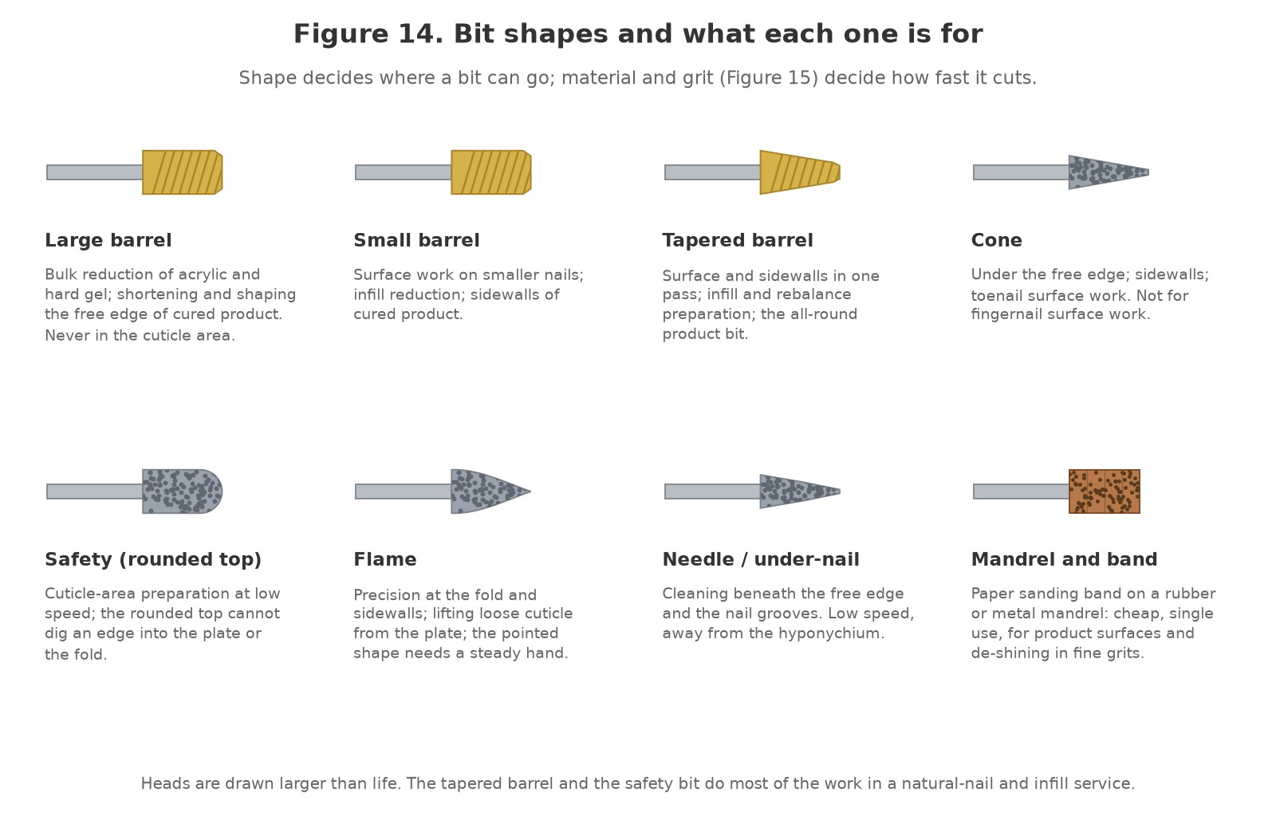
Figure 14. Bit shapes and what each one is for. Large and small barrel, tapered barrel, cone, safety (rounded top), flame, needle and the mandrel with a sanding band.
Original illustration © The Looking Glass Beauty School, 2026.

Shapes
Shape | Where it goes | Where it never goes
Large barrel | Bulk reduction of acrylic and hard gel; shortening and shaping the free edge of cured product; flat across the surface | The cuticle area; the natural nail; the sidewalls at an angle
Small barrel | Surface work on smaller nails; infill reduction; the sidewalls of cured product | The cuticle area; the natural nail
Tapered barrel | The surface and the sidewalls of product in one pass; infill and rebalance preparation; the most-used product bit | The natural nail; the fold
Cone | Under the free edge of product; the sidewalls; toenail product surfaces | Fingernail surface work (the point rocks); the hyponychium; the fold
Safety bit (rounded or ball top) | Cuticle-area preparation on the plate beside the fold, at low speed; blending the cuticle zone of an infill | Nowhere else: it is the only shape used in the cuticle area
Flame | Precision at the fold and in the sidewall grooves; lifting loose cuticle from the plate; blending the cuticle zone of product | On living skin; at anything but low speed; in a hand that is not yet steady
Needle / under-nail cleaner | Cleaning beneath the free edge of product and along the grooves; low speed, away from the hyponychium | Beneath the natural free edge; into the hyponychium
Backfill ('French fill') bits | Cutting a new smile line into pink-and-white acrylic for a backfill; used by professionals trained in that service | This course does not assess backfills; the bit is shown so learners recognise it
Mandrel | Carries the sanding band; the band does the work | Without a band; with a band that is split, loose or worn through
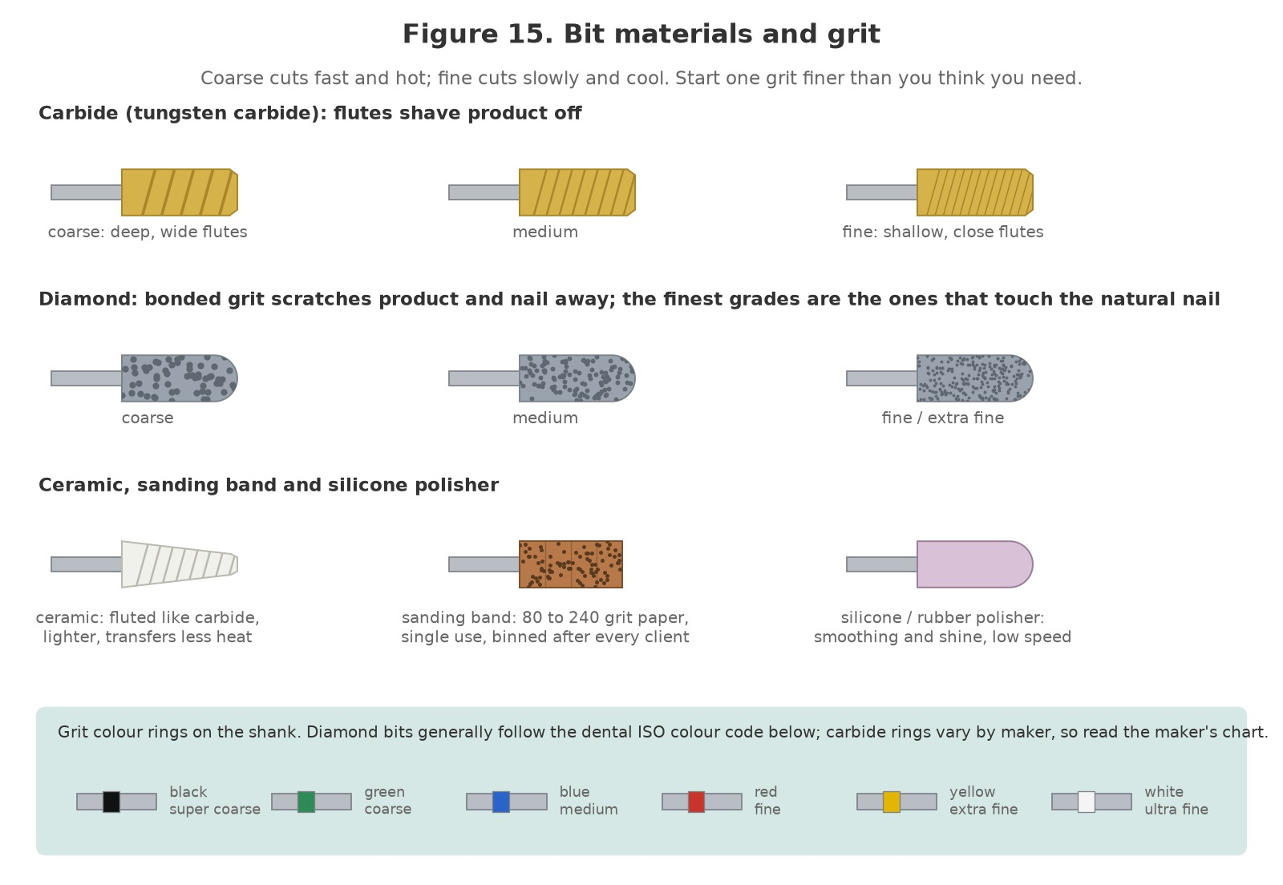
Figure 15. Bit materials and grit. Carbide flutes from coarse to fine; diamond grit from coarse to extra fine; ceramic, sanding band and silicone; and the colour-ring code on the shank.
Original illustration © The Looking Glass Beauty School, 2026.

Grit
Grit is how coarse the cutting surface is. On a sanding band it is a number: 80 and 100 are coarse, 150 medium, 180 medium-fine, 240 fine. On carbide the grit is the depth and spacing of the flutes; on diamond it is the size of the particles. Makers mark the grade with a coloured ring on the shank. Diamond bits generally follow the colour code of the dental standard (black super coarse, green coarse, blue medium, red fine, yellow extra fine, white ultra fine); carbide rings vary from maker to maker, so read the chart for the brand you buy and label your bit stand.
- Coarse cuts fast and hot and leaves a rough surface. It belongs on the bulk of acrylic and hard gel, and nowhere near the plate.
- Medium is the working grade for most product reduction and for gel polish removal.
- Fine and extra fine finish product, blend the cuticle zone and, in the safety and flame shapes, do the only electric-file work that happens near the natural nail.
- Nothing coarser than fine touches the natural nail, and even fine touches it only to remove shine.

Choosing the bit for the task
Task | Bit | Grit | Speed (rpm)
Cuticle-area preparation on the natural nail | Safety bit, diamond | Fine / extra fine | 3 000 to 8 000
De-shining the natural nail | Sanding band or fine silicone | 240 / fine | 3 000 to 5 000
Gel polish: top coat and colour to the base coat | Sanding band or carbide barrel | Medium / fine | 8 000 to 15 000
Builder gel: reduce for an infill or removal | Tapered barrel, carbide or ceramic | Medium | 10 000 to 18 000
Hard gel or acrylic: bulk reduction | Large or tapered barrel, carbide | Coarse, then medium | 15 000 to 25 000
Shaping and refining cured product | Barrel or tapered barrel | Medium, then fine | 10 000 to 18 000
Blending the cuticle zone of product | Safety bit or flame | Fine | 5 000 to 10 000
Under the free edge of product | Cone or needle, diamond | Fine | 8 000 to 12 000
Smoothing and shine on product | Silicone polisher | Fine | 5 000 to 10 000
Toenail product removal (healthy nail) | Cone or tapered barrel | Medium, then fine | 8 000 to 15 000
These are starting points, not laws. The maker's guidance for the machine and the bit, the thickness of the product, the condition of the plate beneath and the professional's own control all move the numbers down. Nothing moves them up except a thicker product and a steadier hand.

Lifespan and when a bit is finished
- Sanding bands: one client. They cannot be disinfected and a used band cuts unpredictably.
- Carbide: months of daily use. A carbide bit that needs more pressure or more speed than it used to is dull, and a dull bit makes heat; replace it.
- Diamond: the grit wears off the high points first. A bit that rubs and polishes instead of cutting is finished.
- Any bit with a bent shank, a chipped head or rust: binned. A bent bit wobbles, vibrates the hand and cuts in a circle instead of a line.
- Silicone polishers: replaced when glazed, cracked or out of round.
ONE BIT DOES NOT DO EVERYTHING — A professional changes bits as the work changes: coarse carbide for bulk, medium for the body of the job, fine for the finish, the safety bit alone for the cuticle area. A single 'all-purpose' bit at one speed is how grooves, heat and thin nails happen.

Chapter 8 — Speed, pressure, angle and heat
Friction makes heat; the professional's job is to stop it reaching the nail bed

Where the heat comes from
A bit abrades a surface by friction, and friction makes heat. The heat produced in any second depends on how fast the bit is turning, how hard it is pressed, how coarse it is and how long it stays on one spot. The nail plate is thin and conducts that heat straight down to the living nail bed, which has nerves. Through a thick layer of product the client feels nothing until the layer is thin; on the natural nail, or on the thin product at the cuticle zone, the client feels heat in two or three seconds and the bed can be burned in five. A burn shows as pain, then a white or pink change in the plate, then, weeks later, the plate lifting from the bed (onycholysis). Everything in this chapter is a way of making less heat, or of moving it away before it matters.

The four things you control
Task on the nail | Typical speed (rpm) | Why
Cuticle-area preparation, natural nail | 3 000 to 8 000 | The plate is thinnest here and the living fold is a millimetre away; only a safety bit, only slow
De-shining the natural nail | 3 000 to 5 000 | Shine off, nothing else; at this speed a fine band floats
Gel polish to the base coat | 8 000 to 15 000 | Thin layers come off quickly; the base coat shows when to stop
Builder gel reduction; blending cuticle zone of product | 5 000 to 18 000 | Lower where the product is thin or near the fold; higher over the apex
Hard gel and acrylic bulk | 15 000 to 25 000 | Thick product takes speed with a coarse bit; the speed drops as the layer thins
Shaping and refining product | 10 000 to 18 000 | Medium speed with a medium bit gives control and an even surface
Under the free edge; silicone finishing | 5 000 to 12 000 | Precision work close to the hyponychium; polishing needs little speed
- Speed. Start at the bottom of the range for the task and go up only if the bit is not cutting. More speed with less pressure, never more pressure with the same speed. The highest speeds are for the bulk of hard product only, and they come down as the layer thins.
- Pressure. The weight of the handpiece and no more: a feather touch that lets the bit float across the surface. If you can see the plate flex, or the product dent, you are pressing. A machine with real torque at low speed makes a light touch possible; a stalling machine teaches a heavy one.
- Angle. The bit flat, parallel to the surface it is working, so its whole working length shares the load (Figure 16). A tilted bit touches on one edge, and that edge concentrates all the pressure and all the heat into a line: a groove in product, a ring of fire in the natural nail.
- Time on the spot. The bit moves from the moment it touches and is lifted every two or three seconds. A bit that dwells makes a hot spot; a bit that travels spreads the same heat across the nail, where it can escape.
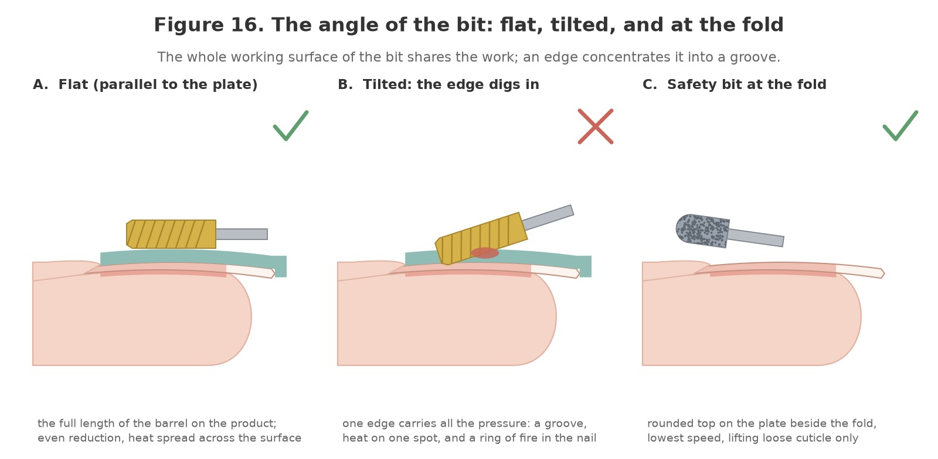
Figure 16. The angle of the bit: flat, parallel to the surface, so the whole working length shares the work; tilted, so one edge digs in; and the safety bit at the fold, rounded top on the plate beside the fold at the lowest speed.
Original illustration © The Looking Glass Beauty School, 2026.

Holding the handpiece and supporting the hand
- Hold the handpiece like a pen, low down near the chuck, with a light grip. A tight grip tires the hand, transmits vibration and makes every movement coarse.
- Brace your little finger or ring finger on the client's hand or on your own supporting hand, so the bit moves from the fingers and not from the shoulder.
- Hold the client's finger firmly between the thumb and forefinger of your other hand, with the hand resting on the desk or a cushion, and turn the finger to present each part of the nail to the bit. Bring the nail to the bit; do not chase the nail with the machine.
- Both forearms supported on the desk; the extraction hood under the work; the cable clear.
- Work in short passes along the nail or along the fold, lifting between passes; never in circles on one spot.

Direction of rotation and direction of travel
At the point where the bit touches the nail, its surface is moving in one direction. Travel the bit with that direction and it pulls itself along smoothly; travel against it and it grabs, skips and throws dust at you. Along a sidewall this means the rotation must run from the fold towards the free edge on the side you are working, and when you cross to the other sidewall the rotation runs the wrong way, so the direction is switched, with the bit stopped. Most right-handed professionals work in forward and switch to reverse for the far sidewall; left-handed professionals the opposite. Learn it on cured product until it is automatic; the grab of a bit running against its travel is how sidewalls get nicked.
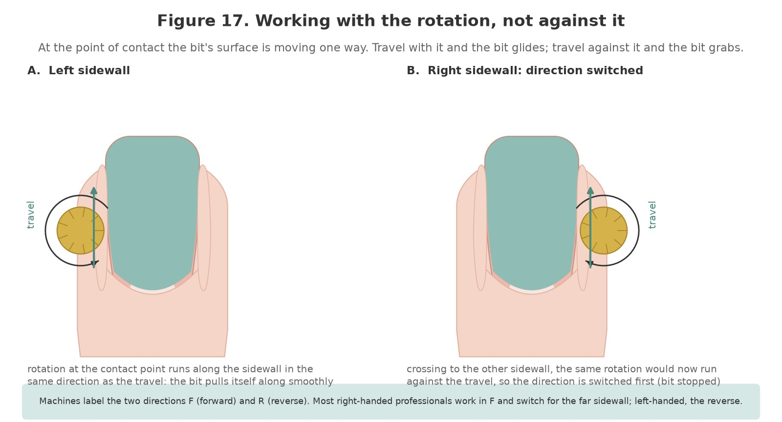
Figure 17. Working with the rotation, not against it. On the left sidewall the rotation at the contact point runs with the travel; crossing to the right sidewall the direction is switched first, with the bit stopped, so it still does.
Original illustration © The Looking Glass Beauty School, 2026.

The heat check
- Before the bit touches, tell the client: 'If any nail feels warm, say so at once and I will stop.' Agree a signal (a lifted thumb on the other hand) so they do not have to speak.
- Every few seconds, lift the bit and touch the nail with your own finger. Warm is the limit; hot is already too far.
- Alternate between nails on a thick removal so each nail cools while the next is worked.
- Dark product, thick product and a thin plate all heat faster. Slow down for them.
- If the client reports heat: lift at once, let the nail cool completely, then continue at a lower speed, with lighter pressure and more frequent lifting. Never say 'nearly done'.
- Check the handpiece too. A hot handpiece means a long session, a dirty chuck or a bent bit; rest it and look.

Rings of fire
Rings of fire are crescent-shaped grooves or red marks in the natural nail beside the cuticle area, cut by the edge of a bit that was tilted, pressed, or the wrong shape for the fold. They expose the thinnest part of the plate over the matrix end of the bed, they are painful, and they cannot be repaired; they grow out over months, and the client remembers who made them. Prevention is the whole of this chapter in one place: a safety bit, flat, at the lowest speed, with feather pressure, moving and lifting. If you cause one, the electric file is finished on that nail; tell the client honestly, record it on Form E, and review your bit, angle and speed before the next client.
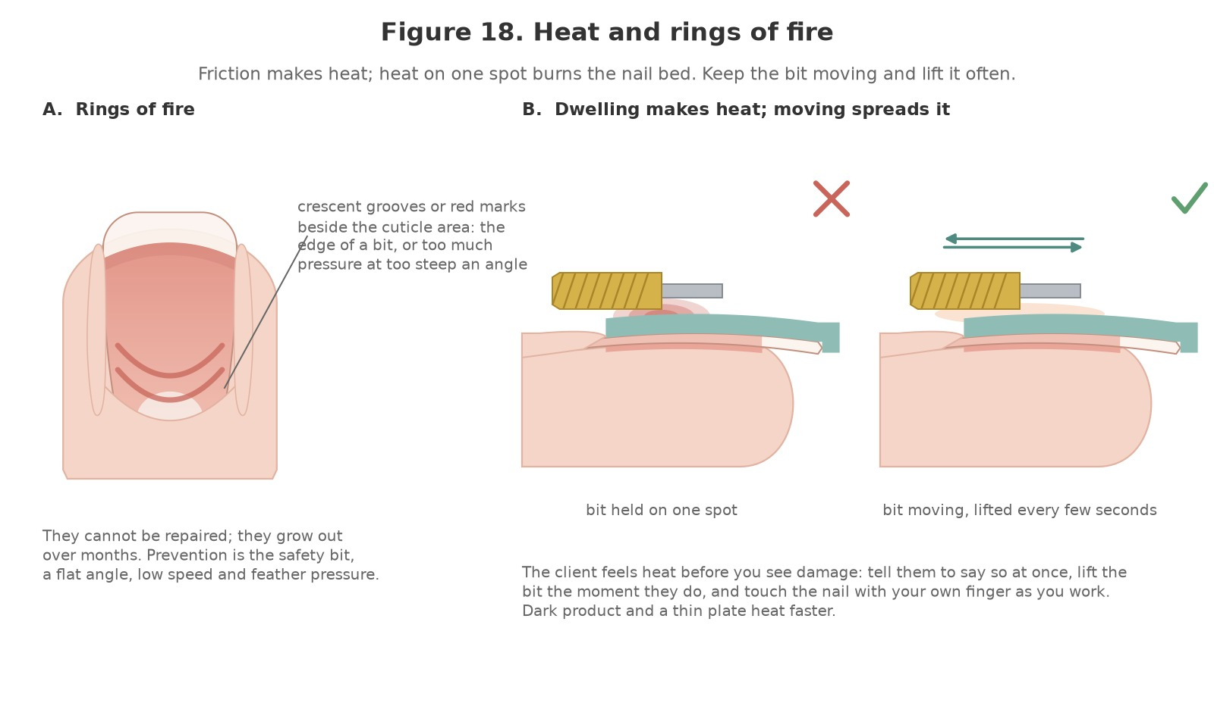
Figure 18. Heat and rings of fire. A: crescent grooves beside the cuticle area from a bit edge or too much pressure at too steep an angle. B: a bit held on one spot builds heat under it; a bit that moves and is lifted every few seconds spreads it.
Original illustration © The Looking Glass Beauty School, 2026.

Reading the dust and the sound
Sign | Likely cause | Action
Fine white powder, little of it | Fine grit, light pressure: correct | Carry on; keep the extraction capturing it
Big curls or flakes of product | Coarse carbide on bulk product | Correct on thick product; change down a grit as the layer thins
Dust gathering fast on the natural nail | The plate is being thinned | Stop. The nail is not a surface to reduce
A hot or acrid smell | Too fast, too much pressure, or a dull bit dwelling | Lift; cool; lower the speed; check the bit
A white or pale patch appearing in product or plate | Friction heat has changed the material | Lift at once; cool; that spot is not touched again
The bit skips, grabs or chatters | Running against its travel, a bent bit, a loose chuck, or too little torque for the speed | Lift; check direction, seating and the bit; raise the speed slightly rather than the pressure
The sound rises in pitch under load | Pressing: the motor is working against you | Lighten the touch; let the bit float
THE CLIENT IS THE THERMOMETER — A client who has been told to report warmth and feels able to will tell you before the bed is harmed. A client who was told to sit still and be brave, or who cannot feel their fingertips, cannot. Brief every client, every time, and treat the signal as an order, not an opinion.

Chapter 9 — Health, safety, hygiene and ergonomics
Preventing exposure, cross-contamination and avoidable injury

Risk assessment and hierarchy of controls
The safest approach removes or reduces a hazard before relying on personal protective equipment. A salon COSHH/risk assessment should consider the product, task, route of exposure, frequency, quantity, ventilation, people at risk and emergency action.
Control level | Electric-file example
Eliminate | Do not use a hobby rotary tool or an unmarked machine; do not use the electric file on a nail that should not be filed at all.
Substitute | Choose the finest grit and the lowest speed that do the job; a safety bit instead of a sharp one at the fold; a hand file on the natural nail where the plate is thin.
Engineering control | Local exhaust extraction at the desk that captures dust at the source; a low-vibration handpiece and concentric bits; a machine with real torque at low speed so pressure is never the answer.
Administrative control | Training, consultation, the speed and bit rules in Chapter 8, bit and direction changes only with the machine stopped, lifting the bit every few seconds, bit decontamination schedules, breaks from filing, and incident reporting.
PPE | A fitted FFP2 or FFP3 mask where the assessment requires it, eye protection, apron, and gloves for decontamination; a mask and glasses offered to the client. PPE is the last line, not the only control.

Routes of exposure
Route | Examples | Control
Skin | Friction heat through the plate, a bit catching the fold, dust settling on hands and forearms, disinfectant and acetone on the hands | Flat bit, low speed, feather pressure, lifting often; safety bits only at the fold; dust brushed off under extraction and washed off before breaks; gloves for decontamination; hand care
Eyes | Dust and product fragments thrown from the bit; a snapped sanding band; disinfectant splash | Eye protection for the professional during filing and offered to the client; no touching the face; eyewash access; follow the SDS first aid for chemicals
Inhalation | Fine dust from cured acrylic and gel, keratin dust, disinfectant vapour | Extraction at the source for every minute of filing; the finest grit and lowest speed that do the job; a fitted mask; filters and bags changed as the maker says, wearing a mask
Ingestion | Eating/drinking at workstation, contaminated hands | No food/drink/smoking in treatment area; wash hands before breaks
Injection/cut | A bit edge or point catching the fold, the sidewall or the hyponychium; a sanding band that splits; a broken bit | Safety bits at the fold, bits travelling away from skin, the client's finger held firmly, bands checked before use; stop, first aid and the blood procedure if skin is broken

Cleaning, disinfection, sanitation and sterilisation
These terms are not interchangeable. Cleaning physically removes dirt and organic matter and must occur before effective disinfection or sterilisation. Sanitation reduces contamination to an acceptable routine level. Disinfection inactivates many disease-causing microorganisms but may not destroy bacterial spores. Sterilisation is a validated process intended to destroy all viable microorganisms, including spores.
Item/method | Correct approach
Hands/skin | Wash with liquid soap and water when visibly dirty and at the start/end of work; dry thoroughly. Use an appropriate hand rub on visibly clean hands where policy allows. Moisturise between services/after work to protect the barrier.
Work surface, handpiece, control unit and extraction hood | Clean visible soil, then apply a compatible disinfectant for the stated contact time. Wipe the handpiece, the control unit, the switches and the extraction hood with a cloth; never spray liquid into the handpiece, the chuck or the unit.
Porous files, buffers, orangewood sticks, sanding bands | Treat as single-client/single-use unless the manufacturer and local policy provide a validated decontamination route. Sanding bands are always single use. Do not share between clients.
Metal pusher, nippers, clippers; carbide, diamond and ceramic bits | After every client: safely transport as used, clean with detergent/mechanical action (a brush or an ultrasonic bath), rinse/dry, inspect, then disinfect using a compatible product at correct dilution/contact time. Sterilise by validated steam autoclave if the risk assessment/local authority requires it.
Blood-contaminated reusable tool | Stop, wear appropriate PPE, quarantine safely and follow the blood/body-fluid procedure. Dispose as appropriate or use a validated cleaning and steam-sterilisation route; do not simply wipe and reuse.
Autoclave | Steam steriliser used only for compatible instruments with validated cycles, packaging/loading, records, routine tests and maintenance. It is the recognised salon method when sterilisation is necessary.
UV cabinet/light box | Storage aid for already clean/decontaminated instruments. It must not be described as a reliable steriliser.
Glass-bead unit, hot-air oven, boiling water | Do not present as validated salon sterilisation. Current local-authority guidance commonly states that glass-bead units, UV boxes, hot-air ovens and boilers must not be used for sterilisation.
Chemical immersion | Usually disinfection in salon use. A product may make a sterilant claim only under specific validated conditions; follow label, COSHH and local rules and do not casually call a disinfectant 'sterilising solution'.
Sanding bands | Single use. Slid off the mandrel and binned after every client, however clean they look; the paper cannot be disinfected and the band that split on the last client is the one that cuts the next.
Silicone and rubber polishers | Clean with detergent and a brush, rinse, dry, disinfect by immersion for the contact time. Replace when the surface is glazed, cracked or no longer round.
Mandrels, chuck and handpiece nose | Dust brushed out with the machine off; the mandrel cleaned and disinfected like a metal bit; the chuck opened and brushed clean as the maker instructs, never immersed.

Standard between-client sequence
- Remove used disposables and place them directly into the correct waste container.
- Move reusable tools to a designated closed 'used' container; keep them separate from clean tools.
- Clean and disinfect the workstation, hand rest, the handpiece, the control unit and its switches, and the extraction hood, using the correct contact time and without spraying liquid into the equipment.
- Perform the full tool-cleaning and disinfection/sterilisation process. Dry, inspect and store protected.
- Wash and dry hands, replace couch roll/towel and set out only the clean items needed for the next client.
- Record completed scheduled cleaning and any contamination incident.

Blood or skin-break procedure
- Stop the service and move products/tools away.
- Ask the client to apply pressure with clean disposable gauze where appropriate; the professional should wear suitable disposable gloves.
- Do not continue any electric-file work on or near broken skin or active bleeding; the bit and the band that touched it are removed from use.
- Dispose of contaminated single-use materials in the route identified by the local waste assessment. Quarantine reusable tools for validated processing.
- Clean and disinfect the contaminated surface using the salon's blood-spill procedure and product instructions.
- Wash hands after glove removal, document the incident and provide appropriate first-aid/referral advice.

Ventilation, dust and odour
HSE guidance for nail bars and beauticians (HSE COSHH Essentials sheet SR13, "Nail bars and other beauty services") identifies dermatitis, skin allergy, asthma and respiratory symptoms as relevant risks from beauty products and artificial-nail dust. General ventilation helps, but opening a window alone may not control dust at the technician's breathing zone. Use source capture where the assessment requires it, maintain filters and use methods that create the least dust.
- Make less dust: the finest grit and the lowest speed that do the job, product reduced in stages, and the extraction running before the bit starts and until the dust is cleared.
- Position local extraction close enough to capture dust before it crosses the breathing zone.
- Do not rely on a strong smell to judge danger; some hazardous exposure has little odour, and smell perception varies.
- Do not use an ordinary desk fan that blows dust and vapour across the client or room.
- Empty/maintain extraction and waste in accordance with instructions while wearing any identified PPE.

Dust from the electric file
Filing cured acrylic, hard gel, builder gel or gel polish makes a fine dust of acrylate polymer, residual monomer, photoinitiator residues and, from the natural nail, keratin; a lifted or infected nail adds bacteria and fungal spores to it. The finest fraction stays in the air at the height of your face and the client's, and it is both a respiratory irritant and a sensitiser: a professional who is sensitised to acrylates by dust reacts to the uncured product as well. HSE's guidance for nail bars (COSHH Essentials sheet SR13) names respiratory symptoms, asthma and dermatitis as the risks from artificial-nail dust. The electric file makes more dust, faster and finer, than a hand file, and the controls are not optional.
- Local exhaust extraction under the hands, running before the bit starts and until the dust is cleared: a desk-mounted or built-in unit with its filter and bag changed as the maker says, by someone wearing a mask.
- Make less dust: the finest grit and the lowest speed that do the job; product reduced in stages; the bulk of a removal softened by soaking where the product allows.
- A mask that fits. A fitted FFP2 or FFP3 respirator as the risk assessment requires; a loose pleated paper mask is not respiratory protective equipment. The client is offered a mask and eye protection.
- Dust is brushed from the nail under the hood with a soft brush, never blown by mouth or with a canned-air duster, and never wiped across the client's hand with a bare palm.
- Surfaces damp-wiped, not dry-dusted; the desk, the hand rest and the hood cleaned between clients; the bin emptied before it is full.
- Forearms and hands washed before breaks; sleeves and apron free of dust before the next client; dust kept off the face.

Vibration, noise and the hands
Hand-arm vibration syndrome (HAVS) is permanent damage to the nerves, blood vessels and joints of the hand and arm from holding vibrating tools. The Control of Vibration at Work Regulations 2005 require employers to assess and control the risk where it could cause harm, and HAVS and vibration-related carpal tunnel syndrome are reportable occupational diseases under RIDDOR. A professional electric file is a low-vibration tool, far below the levels of a construction tool, but a nail professional holds one for hours every working day, and a bent bit, a dirty chuck or worn bearings multiply the vibration many times. The controls are simple and they also make the work better: a low-vibration handpiece; concentric bits, with bent ones binned; the chuck cleaned daily; a light pen grip; breaks from filing every twenty minutes; hands kept warm; and early reporting of tingling, numbness, loss of grip or white fingertips in the cold. Noise from a professional machine is low; a machine that has become loud is a machine that needs attention.

Ergonomics and prevention of backache/RSI
Area | Good practice
Chair and feet | Use an adjustable supportive chair. Sit back with feet flat or on a footrest; avoid perching or twisting.
Desk and elbows | Use a narrow, stable manicure desk so client and technician do not reach. Support both forearms; aim for relaxed shoulders and elbows near 90 degrees.
Neck and vision | Bring the client's hand into the lit working area instead of bending the neck toward the desk. Consider task lighting or magnification.
Wrist and grip | Keep wrist as neutral as possible, use a light tool grip, support the finger and vary movement. Replace worn files rather than pressing harder.
Client position | Seat the client squarely facing the desk with supported arm and relaxed hand. Ask them not to pull, twist or hold the fingers rigid.
Work pattern | Insert microbreaks, stretch hands/forearms/neck, alternate tasks, schedule realistic service gaps and review symptoms early.
Warning signs | Persistent pain, tingling, numbness, weakness or night symptoms require workload review and appropriate medical/occupational-health advice.

30-SECOND POSTURE RESET — Feet supported; hips back; shoulders down; client close; both forearms supported; wrist neutral; the handpiece held like a pen with a light grip; the extraction hood under the hands; the cable clear of the desk edge. Reset between every client and every twenty minutes of filing.

Chapter 10 — UK legislation, insurance, data and advertising
How the rules connect to everyday salon decisions
Legislation changes and local requirements differ. The following summary explains relevance to electric-file work in Great Britain as at November 2026; it is educational guidance, not legal advice. Businesses must check current official sources, insurer terms and their own local authority before delivery and at each document review.

Core legislation and guidance
Law or requirement | Relevance to a nail professional using an electric file
Health and Safety at Work etc. Act 1974 | Creates general duties to protect employees and others, including clients, so far as reasonably practicable. In practice: a risk assessment that names the electric file, safe systems of work (the speed, bit and heat rules), training, maintained equipment, consultation and incident action.
Control of Substances Hazardous to Health Regulations 2002 (COSHH) | Requires employers to assess and prevent or adequately control exposure to hazardous substances. Filing dust from cured acrylic and gel is a hazardous substance under COSHH: a respiratory irritant and, because it still contains acrylate polymer and residual monomer, a sensitiser. Keep SDS for the products you remove, use extraction and masks, train staff, manage dust and review the assessment when equipment or products change.
Personal Protective Equipment at Work Regulations 1992, as amended in 2022 | Where risk remains after other controls, employers must provide suitable PPE free of charge, train workers and maintain it. For the electric file this means a mask that actually fits (FFP2 or FFP3 to the assessment; a loose paper mask is not RPE), eye protection, and gloves for decontamination. The 2022 amendment extends relevant duties to limb (b) workers.
Reporting of Injuries, Diseases and Dangerous Occurrences Regulations 2013 (RIDDOR) | Specified work-related injuries, dangerous occurrences and diagnosed occupational diseases must be reported by the responsible person. Diagnosed occupational dermatitis, occupational asthma, hand-arm vibration syndrome and carpal tunnel syndrome linked to vibrating tools are all on the RIDDOR list. Not every chip, rash or complaint is reportable; use HSE's current decision guidance.
Data Protection Act 2018 and UK GDPR | Client contact details, consultation records, health information and photographs are personal data; health data is special-category data. Identify an Article 6 lawful basis and an Article 9 condition, give privacy information, minimise collection, secure records, set justified retention periods, support rights and separate treatment consent from marketing consent.
Cosmetic Products Enforcement Regulations 2013 and retained Cosmetic Regulation 1223/2009, as amended | Cosmetic nail products supplied in GB must meet safety, responsible-person, labelling and notification requirements. The products you reduce and remove are cosmetics: keep their SDS, know what is on the nail before you file it, and do not file an unknown product of unknown origin without the client's history.
Provision and Use of Work Equipment Regulations 1998 (PUWER) | Work equipment, which includes the electric file, its handpiece and bits, and the extraction unit, must be suitable for its purpose, maintained in a safe condition, inspected where deterioration could lead to danger, and used only by people who have received adequate training and information. Keep the manufacturer's instructions, a maintenance and inspection record (Form G), and this course certificate as the training evidence.
Local Government (Miscellaneous Provisions) Act 1982 | In England outside London, local authorities can adopt licensing/registration provisions for specified treatments and may impose local byelaws or special-treatment conditions. Coverage differs between authorities, so each business and learner must check the authority where they practise and meet insurer requirements.
London Local Authorities Act 1991 | In London, premises offering nail treatments generally need a Special Treatment Licence, applied borough by borough with local conditions on qualifications, hygiene and premises. Check the relevant borough before trading.
Civic Government (Scotland) Act 1982 | In Scotland, licensing of relevant treatments and premises operates under this Act through the local licensing authority. Check the authority where you practise.
Public Health (Wales) Act 2017 | In Wales, this Act established a special-procedures licensing framework. Nail services are not currently within the mandatory licensing categories, but practitioners in Wales must check current Welsh Government and local-authority guidance.
Electricity at Work Regulations 1989 | Electrical systems and work equipment must be maintained to prevent danger and used safely. Visually check the electric file's cable, plug, control unit and handpiece before every day's use, keep liquids away, remove faults from use, charge cordless handpieces only with the maker's charger, and arrange competent inspection/testing based on risk. The law does not automatically demand annual PAT testing for every appliance.
Waste Electrical and Electronic Equipment Regulations 2013 (as amended) | Electric files, handpieces, control units, batteries and extraction units must enter an appropriate WEEE reuse/recycling route when discarded; batteries go to a battery collection point. Do not place electrical items in normal waste; use supplier take-back or an authorised business-waste route and retain records where required.
Consumer Rights Act 2015 | Services must be performed with reasonable care and skill, information relied on by the consumer can become binding, and pricing must be clear. Avoid unrealistic guarantees and maintain complaint/rectification procedures.
Employers' Liability (Compulsory Insurance) Act 1969 | Most businesses employing staff must hold employers' liability insurance meeting legal requirements and display/make the certificate accessible. This is separate from public and treatment liability.
Workplace (Health, Safety and Welfare) Regulations 1992 | Relevant to safe, clean and suitable workplaces, including ventilation for a dust-producing process, lighting over the nail, temperature, welfare and workstation conditions.
Equality Act 2010 | Service providers and educators must not unlawfully discriminate and should consider reasonable adjustments. Adjustments can change access or assessment method but cannot remove essential safety and competence standards.
Control of Vibration at Work Regulations 2005 | Employers must assess and control the risk from hand-arm vibration where it could cause harm. A professional electric file gives low vibration, but a nail professional holds one for hours a day, every day, and a bent bit or a worn handpiece multiplies it. Choose low-vibration equipment, discard bent bits, keep a light grip, take breaks, keep hands warm and report tingling, numbness or white fingers early.
Supply of Machinery (Safety) Regulations 2008 and product marking | Machines placed on the GB market must meet essential safety requirements and carry the UKCA or CE marking with the maker's details and instructions in English. Buy from a reputable supplier, keep the instructions, and do not use an unmarked machine or one sold as a hobby or craft tool for client work.

Whatever the nation, always confirm licensing and registration requirements with your own local authority and your insurer before trading. Many insurers ask for evidence of specific electric-file training before they will cover its use: keep this course certificate with your policy documents.

Public liability, treatment risk and product liability
Public liability insurance is not one of the Acts listed above, but it is an essential business control and may be required by venues, landlords, local authorities, training providers or contracts. A nail professional should confirm that cover includes the exact treatments, products, teaching activities, students/models, premises and working arrangements. Treatment/professional liability and product liability may be included or separate. Policy conditions often set qualification, age, consultation, record-retention, patch-testing and incident-notification requirements.
- Never assume the salon policy covers a self-employed professional or educator; obtain written confirmation.
- Notify the insurer promptly about an adverse reaction, injury, complaint or potential claim according to the policy. Do not admit liability or alter records.
- Keep factual, contemporaneous treatment and training records for the period agreed with the insurer and documented in the business retention schedule.
- If employing anyone, confirm employers' liability and health-and-safety duties in addition to public/treatment cover.

Data protection in consultation and case studies
Principle | Salon action
Transparency | Give a privacy notice explaining controller identity, purposes, lawful basis/condition, recipients, retention, security and client rights.
Data minimisation | Ask only what is necessary for safe treatment. A full GP address or unrelated medical history is normally unnecessary.
Health data | Document the relevant Article 6 lawful basis and Article 9 condition. Explicit consent may be available where genuinely appropriate, but treatment consent and data-processing conditions are different legal concepts.
Security | Lock paper files; use access-controlled, backed-up systems; avoid client details in personal messaging/photo galleries; restrict staff access.
Accuracy | Confirm changes at every appointment and record what the client said without turning observations into a diagnosis.
Retention | Use a written schedule based on purpose, insurer/legal advice and limitation periods; review and securely delete/anonymise when no longer needed.
Photographs | Use separate optional consent. State educational/assessment/marketing uses individually, avoid identifying features where possible and never post a case-study image automatically.
Breach response | Contain, assess, document and report qualifying personal-data breaches to the ICO within required timescales where applicable; inform affected people when high risk requires it.

Advertising Standards Authority (ASA) and CAP guidance
Advertising includes websites, booking pages, social media, paid posts, influencer content, leaflets and claims made in before/after images. The ASA/CAP position is that beauty marketers must hold evidence for objective efficacy claims and must not exaggerate effects.
Avoid | Use instead
'Painless, no-heat removal' or 'drill-free' | 'Designed for longer wear than traditional lacquer; individual wear varies with nail condition, lifestyle and aftercare.'
'Repairs weak or damaged nails' | 'Removes the old product without damage to the natural nail when carried out correctly; the natural nail is not thinned.' Never claim the electric file strengthens or repairs a nail.
'Completely safe', 'non-toxic' or 'allergy-free' | Describe specific product information accurately and acknowledge that adverse reactions are possible.
'Treats fungus', 'kills infection' or 'cures green nail' | State that suspected infection cannot be treated cosmetically and requires medical/pharmacy advice.
'Qualified nail technician' based only on this CPD activity | 'Trained in electric-file technique (CPD)', with the underlying qualification described accurately.
Heavily retouched before/after images or inconsistent lighting | Use comparable lighting/angle, retain originals, obtain consent and disclose relevant editing/filters.
'Best', 'number one' or award claims without evidence | State the exact verifiable award, year and category; do not imply a wider win than was achieved.

ASA RESOURCE — Learners should review the current ASA/CAP 'Beauty and Cosmetics: General' guidance before advertising: https://www.asa.org.uk/advice-online/beauty-and-cosmetics-general.html

Electrical and electric-file checklist
- ☐ The machine is a professional electric file from a reputable supplier, UKCA or CE marked, with instructions in English and the 3/32-inch shank.
- ☐ Plug, cable, control unit, handpiece and charger show no damage, heat marks, strain or exposed parts; the cable is routed clear of the desk edge and the client.
- ☐ The chuck is clean, the bit seated and tugged, and the bit runs true in the air before it touches a nail.
- ☐ The extraction unit runs whenever the machine does; its filter and bag are within the maker's change interval.
- ☐ The machine is kept away from water and acetone, used without unsafe adaptors or trailing leads, and cordless handpieces are charged only with their own charger.
- ☐ User checks, inspection/test intervals and maintenance are based on risk and recorded on Form G; an arbitrary annual sticker is not treated as the only control.
- ☐ Faulty equipment is unplugged, labelled and removed from use pending competent repair or WEEE disposal; batteries go to a battery collection route.

Chapter 11 — Preparing the natural nail with the electric file
Shine off, cuticle off the plate, and nothing else
Natural-nail preparation is the only part of this course where a bit works on the natural nail itself, and it is where most electric-file damage in salons is done. The decision to use the machine here is made nail by nail at the consultation: a healthy plate of normal thickness, intact skin, a client who can feel and report heat, and a professional whose hand is steady at 3 000 to 8 000 rpm. Anything less, and the stage is done by hand with a pusher, a fine file and a buffer, exactly as the learner was taught at Level 2. Using the hand tools is never a failure; using the machine on the wrong nail is.

The sequence
- Consultation and Form A complete; the stop signal agreed; extraction on; mask on; the client's hand on the rest.
- Shorten and shape the natural free edge with a hand file (180 grit for length, 240 to refine), the finger supported. The electric file does not shape the natural free edge on this course.
- Push the proximal fold back gently with a rubber-tipped or metal pusher, lifting the loose cuticle away from the plate. The pusher, not the bit, moves the fold.
- Fit a fine or extra-fine diamond safety bit, tug it, set 3 000 to 5 000 rpm (never above 8 000 here) and the direction for the sidewall you start on.
- Lay the rounded top of the bit flat on the plate beside the fold, not on the fold, with feather pressure, and travel along the fold from one sidewall to the other in a short pass. Lift. Two or three passes lift the loose, non-living cuticle from the plate; the eponychium is never touched.
- Switch direction (bit stopped) and travel the other way if the sidewall grooves need clearing; a fine flame bit, flat and slow, reaches a groove the safety bit cannot.
- Brush the dust away under the hood with a soft brush. Look: the plate beside the fold should be clean and matte, with no pink flush, no shine spots and no groove.
- De-shine the plate with a 240-grit sanding band or a fine silicone bit at 3 000 to 5 000 rpm, lying flat along the plate and floating over it. The surface goes matte and nothing more; two or three passes, lifting between them. On a thin, young or small nail, a hand buffer does this stage instead.
- Cleanse and dehydrate the plate as the coating system directs, with a lint-free wipe. Inspect every nail under good light from above and from the side before any product goes on.
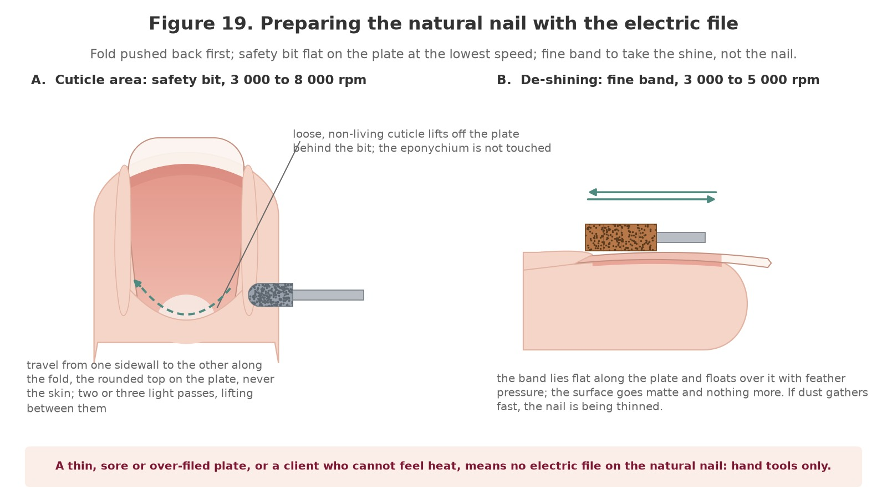
Figure 19. Preparing the natural nail with the electric file. A: the safety bit flat on the plate beside the pushed-back fold, travelling from one sidewall to the other at 3 000 to 8 000 rpm. B: a fine band floating over the plate at 3 000 to 5 000 rpm to take the shine, not the nail.
Original illustration © The Looking Glass Beauty School, 2026.

Preparation faults and what they mean
Preparation fault | What you see | Cause and prevention
Over-thinned plate | A pink flush through the plate, a plate that flexes, dust gathering fast, the client feeling heat | Too long on the plate, too much pressure or too coarse a band. De-shining takes shine, not nail: feather pressure, fine grit, two or three passes, then stop
Rings of fire | Crescent grooves or red marks beside the cuticle area | A bit edge tilted into the plate, a non-safety bit at the fold, or pressure. Safety bit only, flat, slow, lifting
Nicked fold or sidewall | A graze or a bleed at the fold or in a groove | The bit on skin, or running against its travel so it grabbed. The rounded top stays on the plate; direction set for the side being worked
Cuticle left on the plate | A translucent film that lifts the coating within days | The pusher skipped, or the bit rode over the cuticle instead of under it. Push back first, then the bit lifts what the pusher loosened
Shine spots | Glossy patches, usually at the sidewalls and under the fold | The band floated past them. Look under a light from the side before the dehydrator
Heat reported | The client signals or flinches | Dwelling, pressure, or a thin plate. Lift, cool, slower and lighter, or hand tools on that nail
IF IN DOUBT, HAND TOOLS — The pusher, the fine file and the buffer prepare a natural nail perfectly well. The electric file prepares it faster on the right nail in the right hand. When either of those is not certain, the right answer is in the drawer, not in the chuck.

Chapter 12 — Reducing and removing product
The electric file takes product off; it never reaches the plate

Know what is on the nail first
Every product has a removal category, and the electric file's role is different in each. A soak-off product is reduced to speed the soak and then soaked; a file-off product is reduced to a thin layer and the last of it is taken by hand or by soaking if the maker allows; and a product you cannot identify is not filed until you can. The client's history, the previous salon's record and the look and feel of the product usually tell you; when they do not, the honest answer is to find out, or to refer, not to guess with a coarse bit.
Product on the nail | What the electric file does | What finishes the job | Bit, grit and speed
Gel polish | Takes the top coat and colour down to the base coat | An acetone soak of the base, 5 to 10 minutes; or the base is kept where the system is designed to be re-coated over it | Sanding band or carbide barrel, medium then fine, 8 000 to 15 000 rpm
Builder gel in a bottle, soak-off | Reduces the old apex and bulk for an infill, or reduces to a thin layer for removal | The soak the maker specifies; for an infill, the thin layer is the base for the new product | Tapered barrel, carbide or ceramic, medium, 10 000 to 18 000 rpm
Builder gel, file-off; hard gel | Reduces to a thin, even layer over the whole plate | A 180 then 240 hand file or a fine bit at low speed for the last of it, floating, never into the plate | Tapered or large barrel, carbide, medium then fine, 12 000 to 20 000 rpm
Liquid-and-powder acrylic | Reduces the bulk, which is most of the time saved | An acetone soak of 15 to 20 minutes for the thin layer that remains; never filed to the plate | Large barrel, carbide, coarse then medium, 15 000 to 25 000 rpm, dropping as the layer thins
Dip powder | Treated as acrylic: reduce the bulk | Soak | As acrylic
Unknown product | Nothing until it is identified | Identify from the client's history or the previous salon; refer if you cannot | No bit

The principles of reduction
- Coarse to fine. The coarse bit takes the bulk and is changed down as soon as the layer thins; the fine bit does the last millimetre. Nothing coarse goes near the plate.
- Flat and moving. The whole length of the barrel on the product, travelling in short passes along the nail, lifted every few seconds, alternating nails.
- Watch the colour. As the product thins it becomes translucent and the pink of the bed and the white of the free edge show through; the lunula and the sidewalls show first because the product is thinnest there. That change is the signal to change down and then to stop.
- Leave a thin, even layer over the whole plate. It is the natural nail's protection, and it comes off by soaking or by hand, not by machine.
- The cuticle zone last and least. The product is thinnest at the fold and the plate thinnest beneath it: a safety bit, low speed, feather pressure.
- Heat checks throughout: the client briefed, your finger on the nail, the bit lifted.
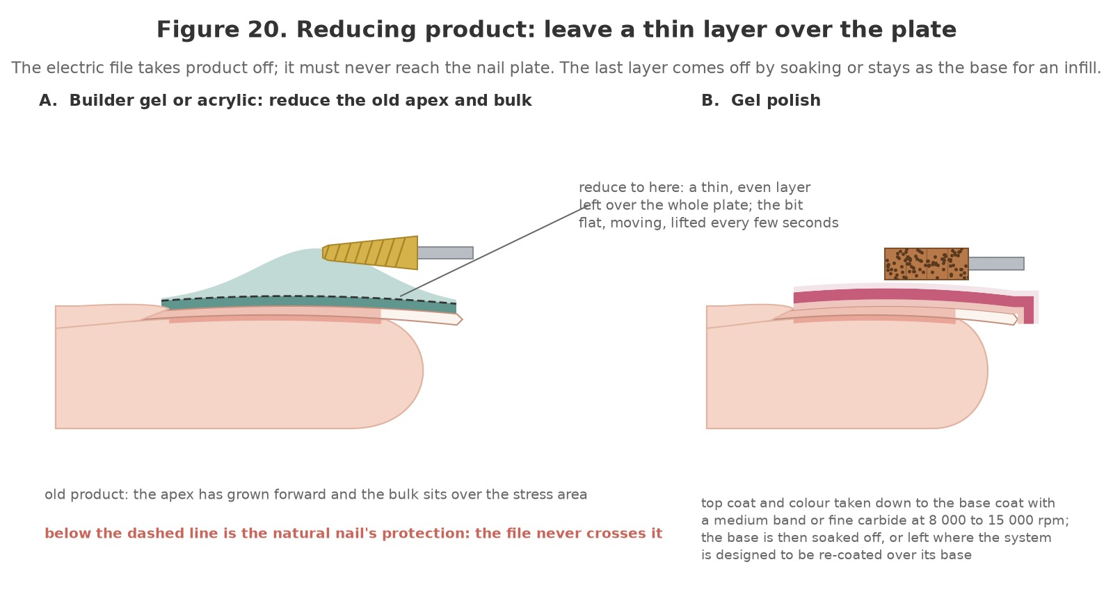
Figure 20. Reducing product: leave a thin layer over the plate. A: an old builder gel or acrylic set with the apex grown forward, reduced with a flat tapered barrel to a thin, even layer; below the dashed line is the natural nail's protection and the file never crosses it. B: gel polish taken down to the base coat, which is then soaked off or kept where the system allows.
Original illustration © The Looking Glass Beauty School, 2026.

Gel polish removal
- Consultation; machine checked; a medium sanding band or a fine carbide barrel seated and tugged; 8 000 to 12 000 rpm to start; extraction on.
- Flat along the nail in short passes from the fold towards the free edge, lifting between passes. The top coat dulls, then the colour thins and the base coat shows pale.
- Stop at the base coat on every nail. On a system designed to be re-coated over its base, the base is kept, cleansed and inspected; otherwise an acetone pad and wrap for 5 to 10 minutes lifts the base, which is slid off with a tool held flat.
- Buff lightly by hand, oil, inspect. A thin coating removed this way leaves the plate as it was.

Builder gel and hard gel: infill reduction
- Identify the product and its category. Machine checked; a medium tapered barrel seated; 10 000 to 15 000 rpm.
- Reduce the old apex first, flat across the surface, until the profile is level; then thin the whole surface evenly, lifting and alternating nails.
- Taper the growth line at the fold to nothing with a fine safety bit at 5 000 to 8 000 rpm, flat, so there is no step between new growth and old product.
- Reduce the sidewalls parallel to the fold with the direction set for the side being worked; switch direction, bit stopped, for the other side.
- Check from the side and down the barrel: a thin, even layer over the whole plate, the natural nail showing pink through it nowhere thinner than anywhere else. Brush the dust away; prepare the new growth with the safety bit as Chapter 11 describes; cleanse.
- For a full removal of a file-off product, continue to a thin layer everywhere, then finish with a 180 and a 240 hand file floating over the surface, or the soak the maker allows. The last of the product is removed by hand because the hand feels the plate.

Liquid-and-powder acrylic
- Identify; machine checked; a coarse carbide large barrel seated; 15 000 to 20 000 rpm, rising only on a very thick set and only with a steady hand.
- Reduce the bulk over the apex and the body of the nail in long flat passes, lifting every few seconds and alternating nails: acrylic holds heat.
- Change down to medium as the colour of the bed starts to show through. Change down again to fine for the cuticle zone and the sidewalls at 8 000 to 12 000 rpm.
- Stop at a thin, even layer. Acetone pads and wraps for 15 to 20 minutes, one hand at a time; the softened product slides off with a tool held flat, and anything that resists is re-wrapped, not filed.
- Buff lightly by hand, wash, oil, inspect every plate under light before anything goes back on.

Toenails
Product on healthy toenails is removed in the same way, usually with a cone or tapered barrel at 8 000 to 15 000 rpm, the foot supported and the extraction brought to it. Toenails are thicker and slower-growing, and the big toe carries more product, so heat builds more slowly but the plate is less forgiving of a groove. A thickened, distorted, discoloured or painful toenail is not within this course whatever the client asks: it is referred to a podiatrist. Hard skin and calluses are never worked with a nail electric file on this course.
THE LAST LAYER IS NOT YOURS — The electric file's job ends at a thin, even film of product over the whole plate. That film comes off by soaking or by a hand file that can feel the nail beneath it. A professional who files 'just a little more' to save five minutes is the professional whose clients have thin nails.

Chapter 13 — Shaping, refining and finishing the enhancement
Shape the product, not the finger
Once product has been applied, in a system the learner is qualified in, the electric file shapes and refines it faster and more evenly than a hand file. The rules do not change: the bit works on cured product only, flat, moving and lifted, with the direction set for the side being worked, and the hand file finishes what the machine starts. Every stage below is practised on cured product on practice tips before it is done on a model.

The order of work
- Shorten and shape the free edge: a barrel or tapered barrel across the tip at 10 000 to 18 000 rpm, the finger supported, taking the corners round or leaving them square as the plan says. Length is checked against the other hand after every nail.
- Sidewalls: the side of the barrel lying along the sidewall, parallel to it, travelling from the fold towards the free edge with the rotation running the same way; direction switched, bit stopped, for the other side. The bit never turns into the lateral fold.
- Surface: the tapered barrel flat across the product from the cuticle zone to the free edge, following the curve, refining the apex and removing bumps; medium grit, then fine, 10 000 to 15 000 rpm.
- Cuticle zone: a fine safety bit or flame at 5 000 to 8 000 rpm, flat, blending the product to nothing at the fold without touching the fold.
- Under the free edge: the side of a fine cone or needle against the underside of the product at 8 000 to 12 000 rpm, travelling away from the hyponychium, tidying the cap and clearing debris; never beneath the natural free edge.
- Check from every angle: from the side for the profile and the apex, down the barrel for the C-curve, from above for the shape and the sidewalls. The eye reads an uneven set before it reads anything else.
- Finish: a silicone polisher at 5 000 to 10 000 rpm to smooth, or a 240 hand file and a buffer, before the top coat or the final buff the system requires. Dust brushed off under the hood; wash or cleanse as the system directs.
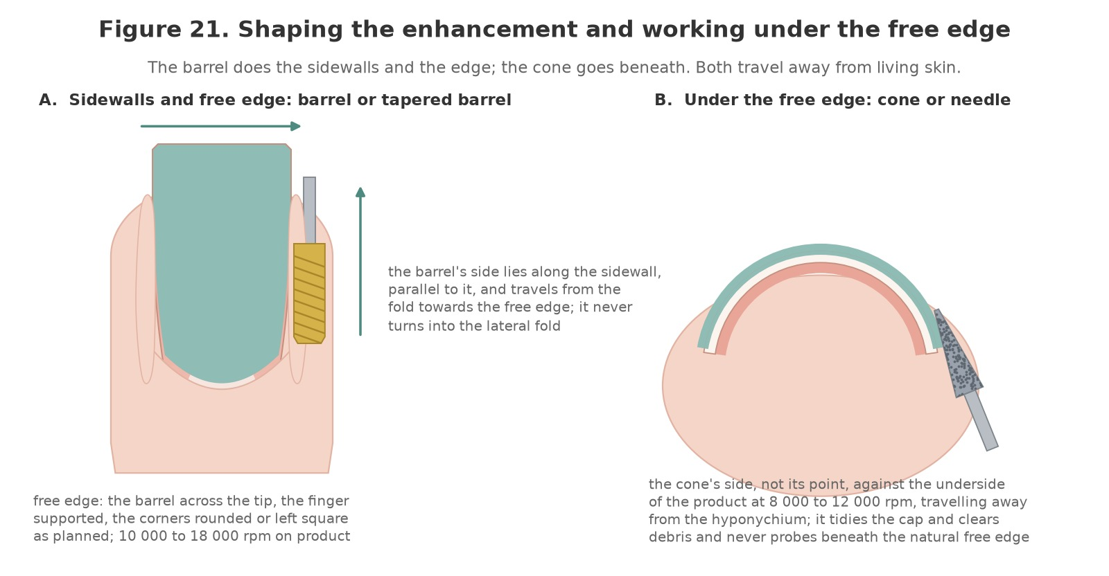
Figure 21. Shaping the enhancement and working under the free edge. A: the barrel's side along the sidewall, travelling from the fold to the free edge, and across the tip to shape it. B: the cone's side, not its point, against the underside of the product, travelling away from the hyponychium.
Original illustration © The Looking Glass Beauty School, 2026.

Backfills and the smile line
Pink-and-white acrylic is maintained by cutting the old white back to a new smile line with a backfill bit and filling the tip with fresh white. The bit is shown in Chapter 7 so learners recognise it; the technique belongs to the acrylic service and is not assessed on this course. A learner qualified in liquid-and-powder acrylic who wants to add backfills practises them on tips with the tutor after the taught day, applying the same rules: flat, moving, medium speed, and the natural nail never reached.

Finishing faults
Finishing fault | Cause | Fix
Flat spots or facets on the surface | The barrel held still or at an angle; passes in one direction only | Flat bit, overlapping passes in both directions, then fine grit and the polisher
A step at the cuticle zone | The safety bit did not blend the product to nothing | Fine safety bit, flat, low speed, feather pressure; check from the side
Nicked sidewall skin | The barrel turned into the fold, or ran against its travel and grabbed | Direction set for the side being worked; the bit parallel to the sidewall; the finger held firmly
Uneven length or shape across the set | Each nail shaped in isolation | Check against the other hand after every nail; shape the thumbs together
A white or dull patch in the product | Friction heat | Lift and cool; lower the speed; do not polish it away, it is a heat mark
Dust left under the free edge or in the grooves | No brush, no under-edge pass | The cone under the edge, a soft brush, and wash or cleanse before the top coat
Scratches that show through the top coat | Coarse or medium grit as the last stage | Fine grit, then the polisher or a buffer, before any top coat
SHAPE THE PRODUCT, NOT THE FINGER — The sidewall is a line of skin a millimetre from the bit. Every pass along it travels away from the fold, with the rotation, with the finger held firmly and the hand braced. The moment a professional feels the bit pull towards the skin, the direction is wrong.

Chapter 14 — Machine care, bit care and keeping the kit safe
A maintained machine is a quiet, cool, concentric one

The checks
Check | How often | What you are looking for
Cable, plug, unit and handpiece: look | Before every day's use | Cuts, kinks, strain at the ends, heat marks, cracks, loose parts. Any fault: unplugged, labelled, out of use
Run in the air and listen | Every bit change | A wobble or a buzz: a bent bit or a dirty chuck. A rising whine or a rattle: the handpiece needs attention
Chuck brushed clean | Every day | Dust packed in the collet makes bits sit off-centre and vibrate
Handpiece temperature | During long removals | Warm is normal; hot to hold is a rest, then a check of the chuck and the bit
Bits inspected | Every decontamination | Bent shanks, chipped heads, dull flutes, bald grit, rust: binned
Carbon brushes (brushed motors) | As the maker says, typically every few months of daily use | Sparking, loss of power, a burning smell: the brushes are worn; replace with the maker's part or send for service
Extraction filter and bag | As the maker says, and when suction falls | Changed with a mask on; a full bag is dust at the desk
Inspection and testing | At the interval the risk assessment sets | A competent check of the electrical safety, recorded on Form G; faults repaired by a competent person or the machine replaced

Bits between clients
Every bit that has touched a client is decontaminated before it touches another: brushed free of dust with the machine off and under extraction; washed in warm water and detergent with a brush, or in an ultrasonic bath; rinsed; dried and inspected; then immersed in a disinfectant for its full contact time, or autoclaved where the maker confirms the bit will take it; rinsed and dried again; and stored closed, dry and labelled. Sanding bands are single use and go straight to the correct waste. A UV cabinet stores clean bits; it does not sterilise anything. Metal bits left in disinfectant beyond the contact time corrode and dull, so timing is part of the routine, and the routine is logged on Form F.
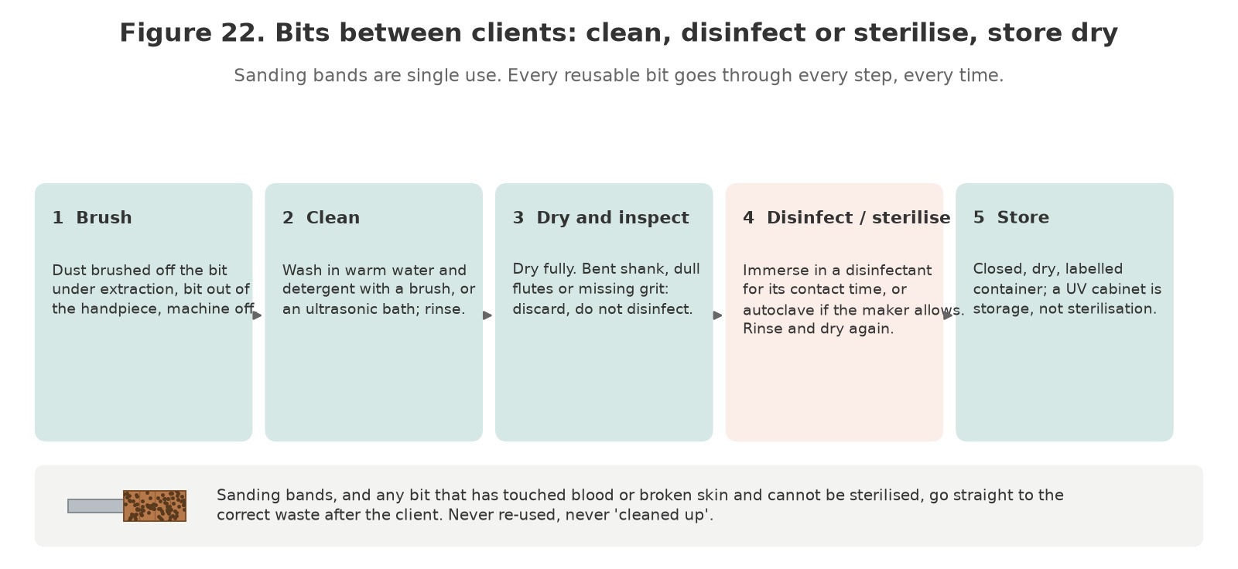
Figure 22. Bits between clients: brush, clean, dry and inspect, disinfect or sterilise, store dry. Sanding bands, and any bit that has touched blood or broken skin and cannot be sterilised, go to the correct waste.
Original illustration © The Looking Glass Beauty School, 2026.

Signs of a failing machine
- A bit that wobbles in every chuck: the chuck or the handpiece bearings are worn, not the bit.
- Speed that hunts up and down under a light load: the control unit or the motor; stop using it.
- Intermittent power, or power only when the cable is held a certain way: a cable fault, the commonest electrical danger at the desk.
- A burning smell, visible sparking at the handpiece, or a handpiece too hot to hold: out of use until checked.
- More vibration than it used to have: bent bit first, then dirty chuck, then bearings.

Mobile and travelling work
- Transport the machine in its case with the handpiece and bits separate; a handpiece rolling loose in a bag comes out with a bent shaft.
- Cordless handpieces charged only with their own charger, never left on charge overnight unattended, and their batteries disposed of through a battery route, not general waste.
- Extraction travels with the machine. A mobile professional without extraction is making dust in a client's home.
- Never used near a bowl of water or a wet hand; never plugged in through a damaged adaptor or a trailing lead across a room.
A WOBBLING BIT IS A BENT BIT — until proven otherwise. Bin it, clean the chuck, try another. The bit that 'only wobbles a little' is the one that vibrates the hand all day and cuts an oval into the first nail it meets.

Chapter 15 — Longevity and troubleshooting
Reading a service that has gone wrong
Problem | Likely cause | Prevention
Rings of fire beside the cuticle area | A bit edge tilted into the plate; a non-safety bit at the fold; pressure | Safety bit only at the fold, flat, lowest speed, feather pressure, lifting
Client reports heat during the service | Dwelling, pressure, speed too high for the layer, a dull bit, a thin plate | Brief the client, lift every few seconds, alternate nails, finger on the nail, slower and lighter
Natural nail thin, pink or sore after a service | The electric file reached the plate: product filed to nothing, or de-shining became thinning | A thin layer left for soaking or hand finishing; de-shining takes shine only; hand tools on a thin plate
Bit grabs, skips or stalls | Running against its travel; a bent or loose bit; too little torque for the speed; a worn band | Direction set for the side worked; bit seated and tugged; speed up a little rather than pressure; a fresh band
Uneven reduction; grooves or facets in product | Tilted bit; one-direction passes; the bit held still | Flat bit, overlapping passes both ways, then fine grit
New product lifts at the cuticle zone after an infill | Old product not tapered to nothing; cuticle left on the new growth; dust left on the plate | Fine safety bit to blend; Chapter 11 preparation of the new growth; brush and cleanse before product
New coating lifts after an electric-file preparation | Plate over-buffed and powdery, or shine spots missed, or dust not removed | Feather pressure for two or three passes; look from the side; brush, wash or cleanse
Nicked sidewall or fold | The bit on skin; running against its travel; the finger not held | Safety bits at the fold; direction right; the client's finger firm in your hand
Dust across the desk, the client and the room | No extraction, or the hood in the wrong place; coarse grit at high speed | Extraction under the hands and running before the bit; finer grit; lower speed
White heat mark in product or plate | Friction heat changed the material | Lift and cool; lower the speed; that spot is not touched again; on the plate, no coating until it has grown out
Hand tingling or numb at the end of the day | A tight grip, a vibrating bit or handpiece, no breaks | Light grip, concentric bits, a serviced handpiece, breaks, warm hands; report symptoms that persist
The machine slows under a light load | Low torque, worn brushes, a cable fault | Service or replace; never compensate with pressure

Setting expectations honestly
- A removal or infill with the electric file is faster, not instant: fifteen to twenty minutes for an acrylic set is normal, and the heat checks are part of the time.
- Nails may feel warm, dry or a little sensitive for a day after a removal; cuticle oil and hand cream help. Pain, grooves or a plate that looks thin are not normal, and the client should say so.
- The natural nail is not damaged by an electric file used correctly. It is damaged by a tilted bit, by pressure, by speed, by the wrong bit at the fold, and by filing product to nothing.
- A client who has been grooved or burned elsewhere may need the whole first service done by hand, with the machine shown and explained, before they will trust it.
- Never promise 'painless'. Promise a professional who stops the moment a nail feels warm, and keep the promise.

Chapter 16 — Contra-actions, adverse reactions and emergencies
Recognise early signs, stop exposure and escalate appropriately

Contra-action or adverse reaction?
A contra-action is an unwanted response or service problem during or after treatment, such as heat discomfort, minor accidental skin abrasion, lifting or dryness. An adverse reaction is a harmful response to a product or process and may include irritant dermatitis, allergic contact dermatitis, respiratory symptoms, chemical eye exposure or burns. The professional does not diagnose the mechanism; they recognise signs, stop exposure, give proportionate first aid and refer.
Event | Possible signs | Immediate management
Friction heat under the bit | Client reports warmth or a sharp burning under the bit; flinches; the nail surface is hot to your touch | Lift the bit at once; let the nail cool; check for a white or pink change in the plate; lower the speed, lighten the pressure and lift more often; never tell the client to tolerate it; record it
Rings of fire | Red crescent marks, grooves or a dip in the plate beside the cuticle area after filing | Stop all electric-file work on that nail; do not file the groove 'smooth'; keep the service minimal; tell the client honestly what has happened and that it will grow out; record on Form E and review bit, angle and speed before the next client
Minor skin break/bleeding | A bit edge or band catches the fold or the sidewall; a nipper injury | Stop; first aid and the blood procedure; the bit and band to the correct waste or quarantine for sterilisation; no further electric-file work near the break; document; refer if needed
Irritant contact reaction | Burning, redness, dryness or cracking after dust, disinfectant or acetone contact | Stop exposure; wash dust off with soap and water; follow the SDS for chemicals; moisturise intact skin; advise medical/pharmacy help if persistent
Suspected allergic contact dermatitis | Itching, swelling, redness, blistering, fingertip changes; may affect eyelids/face/neck; can follow dust exposure as well as uncured product | Stop all relevant nail product and dust exposure; do not re-test; advise GP/dermatology assessment; document the product on the nail, the machine and the extraction in use
Eye exposure | Dust, a product fragment or a splash in the eye; stinging, watering, redness | Irrigate with clean lukewarm water for the SDS time or at least 15 minutes for debris; remove contact lenses if easy; do not rub; obtain urgent medical advice if pain, vision change or a fragment remains
Respiratory symptoms | Cough, wheeze, chest tightness, dizziness or shortness of breath during or after filing | Stop filing, move to fresh air if safe, follow the emergency plan. Call 999 for severe breathing difficulty or collapse. Review extraction, mask fit and the amount of dust being made
Severe allergic/emergency signs | Rapid facial/throat swelling, breathing difficulty, collapse, confusion | Call 999 immediately; follow emergency/first-aid training; do not leave the person alone
Over-thinned or friction-damaged plate | Plate looks thin, pink or translucent, flexes, or feels sore after a service; a white powdery patch on the plate | No further filing of any kind on that nail; no coating over a sore plate; cuticle oil and time; honest explanation; record; review technique before the next client
Possible infection after service | Increasing pain, heat, swelling, pus, spreading redness or green discolouration after a service, especially where the skin was nicked | Do not treat or cover; advise urgent pharmacy/GP/NHS 111 assessment; emergency care if systemically unwell
Bit grabs or skips | The bit jumps across the nail, catches a sidewall or stalls | Lift at once; check direction against the direction of travel (Chapter 8), seating of the bit, speed too low for the torque, or a worn band; check the client's skin before continuing
Dust on the client's face or in the mouth | Visible dust, coughing, eye irritation | Stop; move the extraction; offer water and a wipe; irrigate eyes if needed; review why the extraction did not capture it

General adverse-reaction response
- STOP the treatment and prevent further exposure.
- REMOVE the cause: the bit off the nail and the machine off; dust brushed away under extraction, not blown; any product fragment or debris removed from the eye only by irrigation, never by hand.
- RINSE/WASH or provide first aid according to the exact product SDS and first-aid training.
- ASSESS urgency. Call 999 for emergency signs; otherwise advise NHS 111, GP, pharmacist or occupational health as appropriate.
- RECORD factual signs, times, affected area, the product on the nail, the machine, bit, grit and speed in use, PPE and extraction, action, advice and witnesses. Photograph only with consent and without delaying care.
- REPORT internally, to insurer and under RIDDOR/OPSS rules where applicable. Preserve product/records; do not alter notes.
- REVIEW the risk assessment, the machine and bits, the speed and bit choices, the extraction, training and technique before any further service. Do not perform a salon 'patch test' to prove safety.

Allergy prevention for professionals
- Keep dust off your skin, out of your eyes and out of your lungs every time, not only when you notice it: extraction on, mask on, sleeves clean, forearms and hands washed before breaks.
- Brush dust from the nail under the extraction hood with a soft brush; never blow it, never wipe it across the client's hand with a bare palm.
- Do not touch your face, phone, pen or door handles with contaminated gloves.
- Use extraction for every minute of filing, and the finest grit and lowest speed that do the job: fine dust from a coarse bit at high speed is the dust that reaches the lungs.
- Report hand eczema, cracking, eyelid/facial rash, cough or wheeze early. Once sensitised, continued exposure can jeopardise a technician's career and future medical/dental choices.

Chapter 17 — Aftercare and professional client support
Clear advice protects the service and the natural nail

Aftercare advice
- Nails may feel warm, dry or a little sensitive for a day after a removal or infill; apply cuticle oil to intact skin daily and use a hand cream. Stop if irritation occurs.
- Wear suitable gloves for prolonged wet work, cleaning, gardening and chemical exposure; dry hands thoroughly afterwards.
- Do not pick, peel, bite, prise or file off a coating at home, and do not use a hobby rotary tool on your own nails. Book a professional removal.
- Keep the chosen length practical. If an edge catches, contact the nail professional; do not tear it.
- Book removal, infill or re-application according to growth, condition and product guidance, commonly every two to four weeks.
- Contact the salon promptly for any groove, white mark, tenderness or heat that lasts beyond a day, a nail that looks thin or pink, lifting, a crack, or a green, black or yellow change under a coating.
- Stop product exposure and seek advice for itching, redness, swelling, blistering, burning, fingertip changes or rash on hands, face or eyelids. Seek emergency help for breathing difficulty or throat or facial swelling.
- Do not cover a changed, grooved or sore nail with polish or another enhancement before it has been assessed.
- After a removal, a bare nail benefits from a short rest and daily oil; a nail that was thinned by a previous service may need several weeks before it is coated again.
- Results vary: aftercare supports the natural nail but cannot undo thinning or grooves from a previous service, which grow out over months.

Written aftercare handout
CLIENT TAKEAWAY — AFTER YOUR ELECTRIC-FILE SERVICE: Your nails may feel warm, dry or sensitive for a day; cuticle oil on the skin and a hand cream help. Wear gloves for wet and chemical work. Never pick, peel or file off a coating at home; book a professional removal. Tell us straight away about any groove, white mark, tenderness or heat that lasts, or any colour change under a coating. Stop exposure and seek medical advice for itching, swelling or a rash on the hands or face; call 999 for breathing difficulty, collapse or rapid face/throat swelling.

Professional follow-up
- Record the advice given and the recommended review/removal date.
- Invite the client to report early problems without blame. Early lifting can be removed before moisture is trapped.
- At the next visit, compare wear with the previous plan and adjust length, shape, preparation or system only for a clear reason.
- Do not repeatedly repair the same failure without investigating the preparation, the reduction, the bit and speed choices, the product, the nail condition and the client's lifestyle.
- Document complaints factually, preserve photographs/product records and follow the salon's complaint and insurer-notification procedure.
TEACH-BACK ACTIVITY In pairs, give the client aftercare in 60 seconds. The listener checks that you covered professional removal, wet-work protection, no picking, early reporting of lifting or colour change, and urgent reaction signs. Swap roles and improve one phrase.

Chapter 18 — Course conclusion and next steps
Bringing the learning together before you work on your own clients

What you have covered
Chapter 1 set out ten learning outcomes. By the end of the taught day, and once your three case studies are complete, you should be able to:
- say what an electric file is for, what it is not for, and when a hand file is the honest answer (LO1);
- name the structures of the nail unit and recognise the conditions that mean the machine stays off the nail, or the service is adapted, postponed or refused (LO2);
- consult, record and gain informed consent, and plan an electric-file service around the product on the nail (LO3);
- name the parts and controls of an electric file, set it up, check it and maintain it, and keep the machine and bit record (LO4);
- choose the bit material, shape and grit for each task, and explain how speed, pressure, angle and time on one spot make heat and damage (LO5);
- control dust, vibration and electrical risk under COSHH, PUWER and the vibration regulations, and decontaminate bits between clients (LO6);
- prepare the natural nail with a safety bit at low speed and de-shine it without thinning the plate (LO7);
- reduce and remove gel polish, builder gel, hard gel and acrylic to a thin layer over the plate, without heat, grooves or damage (LO8);
- shape, refine and finish an enhancement with the electric file to a commercial standard (LO9);
- give aftercare, manage contra-actions and reactions, and recognise and respond to rings of fire, friction heat and an over-thinned plate (LO10).

Questions, feedback and reflection
Ask anything you are unsure of before you leave; there is no question too small when the alternative is guessing on a paying client. At the end of the taught day you will complete an evaluation form, and your reflective practice form goes into your portfolio with the case studies; both are in the Tutor and Assessor Pack. Reflection is part of continuing professional development: it is how a day's training becomes a change in the way you work. Your feedback also shapes the next version of this course.

What happens next
- Your CPD certificate is issued by The Looking Glass Beauty School once the theory paper, the practical observation and all three case studies are satisfactory. It carries the course title exactly as accredited and the CPD hours.
- Before offering the service commercially, confirm with your insurer that this CPD course, your underlying qualification and your working arrangements are accepted, and check your local authority's requirements (Chapter 10).
- Complete Form G, the machine and bit record, for the electric file and bits you will use in your own salon, before your first paying client; and add the electric file to your risk assessment and COSHH assessment.
- Start with product removal and infill reduction, where the bit never needs to approach the plate. Add natural-nail preparation with the safety bit once your hand is steady, your speed is low by habit and you can feel the bit floating rather than pressing.

Continuing your development
The electric file is a tool that serves every product you offer. The natural next steps at The Looking Glass Beauty School are the Builder Gel Overlay and Short Extension CPD Course and the Liquid and Powder Acrylic Enhancement CPD Course, both of which are faster and cleaner with a well-handled electric file, and the Gel Polish Nails CPD Course for colour on the natural nail. Support continues after the course: contact the school by phone, message or email with questions about machines, bits, technique or a client you are unsure about. We would rather hear from you than have you guess. Details of every course and how to book are on the school's website and social media.
THANK YOU — for choosing The Looking Glass Beauty School. Lowest speed, lightest pressure, flat bit, keep it moving, lift it often, and listen to the client: the rest is practice on cured product before it is ever practice on a nail.

Chapter 19 — Learner activities and knowledge checks
Work through these before, during and after the taught day

Before the taught day
- Read Chapters 1 to 10 and note three questions to bring with you.
- Write down the make and model of the electric file you own or intend to buy, its speed range, whether it has forward and reverse, and the shank size it takes. If you own one, bring it.
- List the bits you own by shape, material and grit, using Figures 14 and 15. Note any you cannot identify; bring them.
- Write, in your own words, what a ring of fire is, how it happens, and the three things that prevent it.

Knowledge checks
# | Question
1 | Explain the difference between speed and torque, and why a machine with little torque teaches a professional to press.
2 | Name the four things you control that decide how much heat the bit makes, and the sign that tells you heat is building.
3 | What is a ring of fire, how does it happen, and what three things prevent it?
4 | Which bit shape, grit and speed are used in the cuticle area of the natural nail, and why no other?
5 | Why is the bit kept flat to the surface? What happens on one edge?
6 | Explain 'working with the rotation'. What does the bit do when it travels against its rotation, and what do you change?
7 | A client has a thick acrylic set to remove. Describe the reduction from the first bit to the last, including when you stop and what finishes the job.
8 | What is the shank size of a professional electric file, and why must a hobby bit never be forced into the chuck?
9 | List the steps for decontaminating a carbide bit between clients, and say what happens to the sanding band.
10 | Why is filing dust a COSHH matter? Name the three controls that come before a mask.
11 | What does the Control of Vibration at Work Regulations 2005 ask of a nail professional who uses an electric file all day, and what symptoms must be reported early?
12 | A client says her fingertips are numb since chemotherapy. Explain what changes in your service and why.
SCENARIO A — A regular client arrives for an infill with a builder gel set applied here three weeks ago. The growth is 3 mm and one nail has a lifted corner with a shadow under it. Set out your assessment, what the electric file does on each nail and what it does not, what you say, and what you record.
SCENARIO B — Halfway through reducing an acrylic set, the client pulls her hand away and says her thumb is burning. Describe exactly what you do next, what you check on the thumb, what you change for the remaining nails, and what goes in the record.
SCENARIO C — A new client books a 'drill-off' of gel polish done at home with a kit, and shows you crescent grooves beside the cuticle on three nails from her own hobby tool. Explain what you do, what you say, and why.

After the taught day
- Complete three case studies as described in Chapter 1.
- For each, record the product on the nail and its removal category, the machine, the bits, grits and speeds, the heat checks you made, the aftercare given and one thing you would do differently.
- Photograph the nails before and after from above and from the side, with consent, in the same light.

Chapter 20 — Learner forms and client records
Templates to evidence consultation, planning, aftercare and case studies
DATA PROTECTION These forms collect personal and sometimes special-category health data. Do not ask for information that is not necessary for treatment safety.

Form A — Electric-file service consultation and treatment plan
Provider data-protection details
Data controller (school/salon name) | ______________________________________________
ICO registration reference | ______________________________________________
Privacy notice location | ______________________________________________
Lawful basis and special-category condition | ______________________________________________
Retention period | ______________________________________________

Template: the school or salon completes this block before the form is used with clients.
Client/model full name | ______________________________________________
Date of birth / confirmation aged 18+ | ______________________________________________
Telephone or preferred contact | ______________________________________________
Date and time | ______________________________________________
Technician/learner | ______________________________________________

Desired result and lifestyle
What is on the nails now, who applied it and when | ______________________________________________
Work and hand-use considerations | ______________________________________________
Wet work/chemicals/sport/hobbies | ______________________________________________
Previous electric-file work: how it felt, any heat, grooves or sensitivity afterwards | ______________________________________________
Previous removal method and any damage | ______________________________________________

Relevant health, allergy and nail questions
Relevant question | Yes/No | Necessary details
Have you ever had itching, redness, swelling, blistering, nail lifting or rash after gel, acrylic, nail glue, adhesive or dental material?
Do you currently have pain, heat, swelling, broken skin, rash, discharge or colour change around any nail?
Have you been diagnosed with a nail/skin condition that affects this treatment area? If yes, what treatment limitation has been advised?
Are you taking medication or receiving treatment that has recently changed your skin, nails, healing or sensitivity? Record only relevant details.
Do you have diabetes, impaired circulation, reduced sensation, immune suppression or another factor that requires extra care?
Do you have reduced feeling in your fingertips, or anything else that would stop you telling us at once if a nail feels hot?

Professional nail and skin assessment
Area | Observation | Proceed/adapt/postpone/refer
Nail plates
Nail folds/cuticle
Free edges/hyponychium
Colour/attachment
Skin integrity
Other

Agreed treatment plan
Service planned: reduce for infill / full removal / natural-nail preparation / reshape | ______________________________________________
Machine, bits, grits and speed range planned | ______________________________________________
Preparation/adaptations | ______________________________________________
Where hand tools are used instead of the electric file, and why | ______________________________________________
Removal/review date | ______________________________________________
Price | ______________________________________________
Aftercare supplied | ______________________________________________

Treatment consent: I confirm that I have answered the relevant consultation questions honestly, had the planned electric-file service, foreseeable risks (including warmth from friction and dust), alternatives, aftercare and costs explained, and had an opportunity to ask questions. I understand that I must say at once if a nail feels warm and that I may ask the professional to stop at any time.
Client/model signature and date | ______________________________________________
Technician/learner signature and date | ______________________________________________
Tutor signature if assessed | ______________________________________________

Data notice/condition: I have received or can access the provider's privacy notice. Where the provider relies on explicit consent to process relevant health data, that consent must be recorded separately and must meet ICO requirements.
Relevant data-processing record / explicit-consent statement if used ____________________________________________________________________

Form B — Separate photograph consent
Photograph consent is optional and separate from treatment consent. Tick each use agreed. Refusing marketing use must not affect access to treatment.
- ☐ Assessment evidence viewed by The Looking Glass Beauty School educator/quality assurer.
- ☐ Accreditation evidence viewed by the accrediting body where required.
- ☐ Anonymous learner portfolio (no face/name/identifying jewellery).
- ☐ The Looking Glass Beauty School website/social media/marketing.
- ☐ The salon's website/social media/marketing.
How long images will be retained | ______________________________________________
How consent can be withdrawn for future use | ______________________________________________
Model name | ______________________________________________
Model signature/date | ______________________________________________
Learner/educator signature/date | ______________________________________________

Form C — Treatment record
Record field | Details
Date / technician
Consultation changes
Nail condition before service
Product on the nail and its removal category
Machine, bits, grits and speeds used; heat checks and any heat reported
What was reduced or removed, how far, and what finished the job (soak, hand file)
Variations/contra-actions
Outcome
Aftercare and review date
Client comments
Signatures | ______________________________________________

Form D — Three-case-study log

Case study 1
Model code/name | ______________________________________________
Date | ______________________________________________
Service and goal | ______________________________________________
Nail/skin assessment | ______________________________________________
Machine and bits used (shape, material, grit) | ______________________________________________
Speeds used and the heat checks made | ______________________________________________
Preparation/adaptations | ______________________________________________
Outcome and photograph filenames | ______________________________________________
Aftercare | ______________________________________________
What went well | ______________________________________________
What I would improve | ______________________________________________
Follow-up/wear result | ______________________________________________
Educator feedback | ______________________________________________
Result: Satisfactory / Further evidence required | ______________________________________________

Case study 2
Model code/name | ______________________________________________
Date | ______________________________________________
Service and goal | ______________________________________________
Nail/skin assessment | ______________________________________________
Machine and bits used (shape, material, grit) | ______________________________________________
Speeds used and the heat checks made | ______________________________________________
Preparation/adaptations | ______________________________________________
Outcome and photograph filenames | ______________________________________________
Aftercare | ______________________________________________
What went well | ______________________________________________
What I would improve | ______________________________________________
Follow-up/wear result | ______________________________________________
Educator feedback | ______________________________________________
Result: Satisfactory / Further evidence required | ______________________________________________

Case study 3
Model code/name | ______________________________________________
Date | ______________________________________________
Service and goal | ______________________________________________
Nail/skin assessment | ______________________________________________
Machine and bits used (shape, material, grit) | ______________________________________________
Speeds used and the heat checks made | ______________________________________________
Preparation/adaptations | ______________________________________________
Outcome and photograph filenames | ______________________________________________
Aftercare | ______________________________________________
What went well | ______________________________________________
What I would improve | ______________________________________________
Follow-up/wear result | ______________________________________________
Educator feedback | ______________________________________________
Result: Satisfactory / Further evidence required | ______________________________________________

Form E — Adverse reaction / incident record
Client/learner/staff name | ______________________________________________
Date/time/location | ______________________________________________
Treatment stage | ______________________________________________
Factual signs and symptoms | ______________________________________________
Affected nail/skin/area | ______________________________________________
Product names, batches and SDS | ______________________________________________
Machine, bit, grit and speed in use | ______________________________________________
PPE and ventilation in use | ______________________________________________
Immediate action/first aid | ______________________________________________
Emergency service/NHS 111/GP/pharmacist advice | ______________________________________________
Witnesses | ______________________________________________
Photograph consent/file reference | ______________________________________________
Insurer/internal/RIDDOR/OPSS notification decision | ______________________________________________
Follow-up and risk-assessment review | ______________________________________________
Completed by/signature/date | ______________________________________________

Form F — Cleaning and equipment log
Date/time | Item/area | Clean/disinfect/sterilise | Product/cycle/contact time | Completed by | Fault/action

Form G — Machine and bit record
This record is completed twice: first during training, for the machine and bits the tutor demonstrates, and again by the learner for their own kit before offering electric-file services commercially. It is the evidence behind the PUWER and electrical checks in Chapter 10.
 | Machine make/model and serial | Speed range (rpm), torque, forward/reverse | Bits: shape, material, grit | Visual check, inspection/PAT, faults and repairs | Date and signature

Form H — Learner declaration
I understand the scope of this CPD activity and will not describe it as a regulated qualification. I will use the electric file only within my underlying qualifications, competence, insurer and local requirements; only on products I am trained to apply and remove; never on a thin, damaged, separating, sore or infected nail; with extraction, a fitted mask and decontaminated bits every time; and I will keep accurate client, machine and bit records.
Learner name | ______________________________________________
Signature | ______________________________________________
Date | ______________________________________________
Educator name/signature | ______________________________________________

Chapter 21 — References and further reading
Authoritative sources used for technical and regulatory checking
Legislation and guidance can change; the provider reviews this list at least annually and whenever a machine, a bit type, an insurer rule, a local-authority condition or an official safety alert changes.
- UK Parliament — Health and Safety at Work etc. Act 1974 — 1974 — https://www.legislation.gov.uk/ukpga/1974/37
- UK Parliament — Control of Substances Hazardous to Health Regulations 2002 — 2002 — https://www.legislation.gov.uk/uksi/2002/2677
- Health and Safety Executive — COSHH Essentials sheet SR13: Nail bars and other beauty services — 2025 — https://www.hse.gov.uk/pubns/guidance/sr13.pdf
- UK Parliament — Personal Protective Equipment at Work Regulations 1992 (as amended by the Personal Protective Equipment at Work (Amendment) Regulations 2022) — 1992/2022 — https://www.legislation.gov.uk/uksi/1992/2966
- Health and Safety Executive — Personal protective equipment (PPE) at work guidance — 2022 — https://www.hse.gov.uk/ppe/
- UK Parliament — Reporting of Injuries, Diseases and Dangerous Occurrences Regulations 2013 (RIDDOR) — 2013 — https://www.legislation.gov.uk/uksi/2013/1471
- Health and Safety Executive — RIDDOR: occupational diseases — n.d. — https://www.hse.gov.uk/riddor/
- UK Parliament — Electricity at Work Regulations 1989 — 1989 — https://www.legislation.gov.uk/uksi/1989/635
- Health and Safety Executive — Portable appliance testing (PAT) FAQs — n.d. — https://www.hse.gov.uk/electricity/faq-portable-appliance-testing.htm
- UK Parliament — Waste Electrical and Electronic Equipment Regulations 2013 — 2013 — https://www.legislation.gov.uk/uksi/2013/3113
- UK Parliament — Data Protection Act 2018 (with UK GDPR) — 2018 — https://www.legislation.gov.uk/ukpga/2018/12
- Information Commissioner's Office — Special category data: guidance — n.d. — https://ico.org.uk/for-organisations/uk-gdpr-guidance-and-resources/lawful-basis/special-category-data/
- Information Commissioner's Office — How should we obtain, record and manage consent? — n.d. — https://ico.org.uk/for-organisations/uk-gdpr-guidance-and-resources/lawful-basis/consent/
- Information Commissioner's Office — Data protection fee — n.d. — https://ico.org.uk/for-organisations/data-protection-fee/
- UK Parliament — Consumer Rights Act 2015 — 2015 — https://www.legislation.gov.uk/ukpga/2015/15
- UK Parliament — Cosmetic Products Enforcement Regulations 2013 — 2013 — https://www.legislation.gov.uk/uksi/2013/1478
- UK Parliament — London Local Authorities Act 1991 (special treatment licences) — 1991 — https://www.legislation.gov.uk/ukla/1991/13
- UK Parliament — Local Government (Miscellaneous Provisions) Act 1982 — 1982 — https://www.legislation.gov.uk/ukpga/1982/30
- UK Parliament — Civic Government (Scotland) Act 1982 — 1982 — https://www.legislation.gov.uk/ukpga/1982/45
- Welsh Parliament — Public Health (Wales) Act 2017 (special procedures) — 2017 — https://www.legislation.gov.uk/anaw/2017/2
- European Commission — Commission Regulation (EU) 2020/1682 (HEMA and di-HEMA TMHDC restriction, professional use only; as retained in the GB Cosmetics Regulation) — 2020 — https://www.legislation.gov.uk/eur/2020/1682
- European Parliament and Council — Regulation (EC) No 1223/2009 on cosmetic products (applies in Northern Ireland) — 2009 — https://eur-lex.europa.eu/legal-content/EN/TXT/?uri=CELEX%3A02009R1223-20250901
- British Association of Dermatologists — Dermatologists issue warning about UK artificial nail allergy epidemic — 2018 — https://www.bad.org.uk/dermatologists-issue-warning-about-uk-artificial-nail-allergy-epidemic
- British Society for Cutaneous Allergy — Acrylate allergy patient information — n.d. — https://www.cutaneousallergy.org/
- NHS — Nail problems — n.d. — https://www.nhs.uk/conditions/nail-problems/
- NHS — Fungal nail infection — n.d. — https://www.nhs.uk/conditions/fungal-nail-infection/
- Advertising Standards Authority / Committee of Advertising Practice — Beauty and cosmetics: general advice online — n.d. — https://www.asa.org.uk/advice-online/beauty-and-cosmetics-general.html
- Cosmetic, Toiletry and Perfumery Association — Guidance on nail products — n.d. — https://www.ctpa.org.uk/
- Skills England (formerly Institute for Apprenticeships and Technical Education) — Nail services technician occupational standard — n.d. — https://www.instituteforapprenticeships.org/apprenticeship-standards/nail-services-technician/
- UK Parliament — Provision and Use of Work Equipment Regulations 1998 (PUWER) — 1998 — https://www.legislation.gov.uk/uksi/1998/2306
- Health and Safety Executive — Provision and Use of Work Equipment Regulations 1998: guidance — n.d. — https://www.hse.gov.uk/work-equipment-machinery/puwer.htm
- UK Parliament — Control of Vibration at Work Regulations 2005 — 2005 — https://www.legislation.gov.uk/uksi/2005/1093
- Health and Safety Executive — Hand-arm vibration at work — n.d. — https://www.hse.gov.uk/vibration/hav/
- Health and Safety Executive — Respiratory protective equipment at work: a practical guide (HSG53) — 2013 — https://www.hse.gov.uk/pubns/books/hsg53.htm
- UK Parliament — Supply of Machinery (Safety) Regulations 2008 — 2008 — https://www.legislation.gov.uk/uksi/2008/1597
- International Organization for Standardization — ISO 6360-1, Dentistry: Number coding system for rotary instruments, Part 1 (the colour code for abrasive grades) — current edition, available from BSI
All references checked 6 November 2026 as part of the document's first issue.

